**CatCost**

**An Estimation Tool to Aid Commercialization and R&D Decisions for Catalytic Materials**

**Documentation and User Guide**

v 1.1.0

May 2021

CatCost is available at[**catcost.chemcatbio.org**](https://catcost.chemcatbio.org/)

Contact [**catcost@nrel.gov**](mailto:catcost@nrel.gov)

# Notice and Disclaimer

The CatCost software and data, if any, (“Software”) are provided by the National Renewable Energy Laboratory (“NREL”), which is operated by Alliance for Sustainable Energy, LLC (“ALLIANCE”), for the U.S. Department of Energy (“DOE”).

## NOTICE

CatCost™ Copyright ©2018-21 Alliance for Sustainable Energy, LLC All Rights Reserved

This computer software was produced by Alliance for Sustainable Energy, LLC under Contract No. DE-AC36-08GO28308 with the U.S. Department of Energy. For 5 years from the date permission to assert copyright was obtained, the Government is granted for itself and others acting on its behalf a non-exclusive, paid-up, irrevocable worldwide license in this software to reproduce, prepare derivative works, and perform publicly and display publicly, by or on behalf of the Government. There is provision for the possible extension of the term of this license. Subsequent to that period or any extension granted, the Government is granted for itself and others acting on its behalf a non-exclusive, paid-up, irrevocable worldwide license in this software to reproduce, prepare derivative works, distribute copies to the public, perform publicly and display publicly, and to permit others to do so. The specific term of the license can be identified by inquiry made to Alliance for Sustainable Energy, LLC or DOE. NEITHER ALLIANCE FOR SUSTAINABLE ENERGY, LLC, THE UNITED STATES NOR THE UNITED STATES DEPARTMENT OF ENERGY, NOR ANY OF THEIR EMPLOYEES, MAKES ANY WARRANTY, EXPRESS OR IMPLIED, OR ASSUMES ANY LEGAL LIABILITY OR RESPONSIBILITY FOR THE ACCURACY, COMPLETENESS, OR USEFULNESS OF ANY DATA, APPARATUS, PRODUCT, OR PROCESS DISCLOSED, OR REPRESENTS THAT ITS USE WOULD NOT INFRINGE PRIVATELY OWNED RIGHTS.

## DISCLAIMER

Access to and use of this Software shall impose the following obligations on the user, and use of the Software constitutes user’s agreement to these terms. The Software is being provided, without any fee or cost, for internal, noncommercial purposes only and shall not be re-distributed. Please contact the NREL Technology Transfer Office at [technology.transfer@nrel.gov](mailto:technology.transfer@nrel.gov) for information concerning a commercial license to use the Software.

The user agrees to credit DOE/NREL/ALLIANCE in any publication that results from the use of this Software.  The names DOE/NREL/ALLIANCE, however, may not be used in any advertising or publicity to endorse or promote any products or commercial entities unless specific written permission is obtained from DOE/NREL/ALLIANCE.  The user also understands that DOE/NREL/ALLIANCE is not obligated to provide the user with any support, consulting, training or assistance of any kind with regard to the use of the Software or to provide the user with any updates, revisions or new versions of the Software.

USER AGREES TO INDEMNIFY DOE/NREL/ALLIANCE AND ITS SUBSIDIARIES, AFFILIATES, OFFICERS, AGENTS, AND EMPLOYEES AGAINST ANY CLAIM OR DEMAND, INCLUDING REASONABLE ATTORNEYS' FEES, RELATED TO USER’S USE OF THE SOFTWARE.  THE SOFTWARE IS PROVIDED BY DOE/NREL/ALLIANCE "AS IS," AND ANY EXPRESS OR IMPLIED WARRANTIES, INCLUDING BUT NOT LIMITED TO THE IMPLIED WARRANTIES OF MERCHANTABILITY AND FITNESS FOR A PARTICULAR PURPOSE ARE DISCLAIMED.  IN NO EVENT SHALL DOE/NREL/ALLIANCE BE LIABLE FOR ANY SPECIAL, INDIRECT OR CONSEQUENTIAL DAMAGES OR ANY DAMAGES WHATSOEVER, INCLUDING BUT NOT LIMITED TO CLAIMS ASSOCIATED WITH THE LOSS OF DATA OR PROFITS, THAT MAY RESULT FROM AN ACTION IN CONTRACT, NEGLIGENCE OR OTHER TORTIOUS CLAIM THAT ARISES OUT OF OR IN CONNECTION WITH THE ACCESS, USE OR PERFORMANCE OF THE SOFTWARE.

Results generated by use of this Software are dependent on many variables, including the quality of the data entered by the user and any assumptions made by the user in relation to data inputs.  Accordingly, DOE, NREL, and ALLIANCE cannot guarantee any results generated by use of the Software and user is entirely responsible for the results and any reliance on the results.  User shall not claim that DOE/NREL/ALLIANCE authenticate or otherwise agree with the results generated by the Software.

# Table of Contents

Notice and Disclaimer 2

Table of Contents 4

Acknowledgements 5

Key Contributors 5

1 CatCost Overview and Version History 6

2 Accuracy, Sensitivity, and Scenario Analysis 12

3 Global Inputs and Price Scaling: The *“1 Inputs”* Module and the *ChemPPI, CEPCI,* and *UnitConv* Libraries 14

4 Materials Costs: The “*2 Materials”* Module and *Materials Library* 15

5 Processing Costs: General Comments and Estimation Parameters on *“1 Inputs”* 20

6 Processing Costs via a Simplified Step Method: The *“3a Step Method”* Module 23

7 Processing Costs via a Detailed CapEx & OpEx Factors Method: The *“3b Equipment,” “3c Utilities,” “3d CapEx,”* and *“3e OpEx”* Modules and *Equipment Library* 31

8 Process Templates for the Step Method and CapEx & OpEx Factors Method 41

9 Spent Catalyst Value: The *“4 Spent Catalyst”* Module and *Spent Catalyst Library* 47

10 Outputs 57

11 Web Tool Data Import/Export and Visualizations 57

References 61

# Acknowledgements

This research was supported by the U.S. Department of Energy (DOE) Office of Energy Efficiency and Renewable Energy (EERE) Bioenergy Technologies Office (BETO), under Contract DE-AC36-08GO28308 at the National Renewable Energy Laboratory (NREL) and Contract DE-AC05-76RL01830 at the Pacific Northwest National Laboratory (PNNL), and in collaboration with the Chemical Catalysis for Bioenergy Consortium (ChemCatBio), a member of the Energy Materials Network (EMN).

# Key Contributors

**Lead Developer** ­– Kurt M. Van Allsburg (NREL)

**Principal Investigator** ­­­– Frederick G. Baddour (NREL)

**Co-Principal Investigator** – Lesley Snowden-Swan (PNNL)

**Contributors** ­– John Super, Eric Tan, John Frye, James White, Joshua Schaidle, Michael Talmadge, Jesse Hensley, Susan Habas

**Web App and Data Tools Development** ­­– Nicholas Wunder, Kenny Gruchalla, John Yarbrough, Kristi Potter, Matt Jankousky, Andy Young

# CatCost Overview and Version History

## Purpose

Basic catalyst research can benefit from insight on catalyst cost trends and relationships. Early development of pre-commercial catalysts is generally guided by rigorous testing of catalytic performance and durability. However, information about catalyst manufacturing costs may be much more speculative, especially when advanced synthetic techniques not yet used in industry are required. Considering the significance of uncertainty in the cost of manufacture, better cost estimation methods for pre-commercial materials may allow better allocation of R&D resources, throughout the development process, by optimizing materials to meet cost targets in addition to performance and durability targets.

Resources for pre-commercial catalyst cost estimation have been limited prior to the release of CatCost. Evonik Industries provides a simple web-based calculator that estimates certain costs of a catalytic process based on catalyst purchase price, recovery costs, etc. However, it does not support estimation of the catalyst purchase price itself, making it suitable only for established materials. Aspen Technology, Inc. offers a capital cost estimation tool that would support some elements of cost estimation, but it is not catalyst-specific and requires a subscription. Catalyst manufacturers use sophisticated cost models, but their methods are often considered trade secrets. Therefore, the methods described herein represent the state of technology (SOT) for publicly available cost estimators.

The objective of CatCost is to support the catalysis community by integrating essential cost estimation methods into a user-friendly tool. It therefore allows users the opportunity to study a wide range of contributors to uncertainty in catalyst cost while doing little or no tool development of their own.

## Estimation Modules in CatCost

The cost to synthesize a catalyst at industrial scale may be broken down into cost components that are well established in the process design literature.1-4 These components have been implemented into CatCost by a combination of new and literature methods and organized by modules (Table 1.1). A module corresponds to a numbered worksheet in the Excel version of CatCost and to a page in the left-side navigation pane of a catalyst estimate in the web version.

CatCost has been developed with several core tenets to properly model the cost of catalyst manufacture, including: (i) solicitation of industrial review to maximize relevance of the tool to real industry design decisions, (ii) benchmarking and validation of the tool using a range of catalytic materials, and (iii) use of a tiered structure where users can select the level of complexity of the calculation and customize the tool to suit their needs for accuracy and sensitivity analysis (e.g., using CatCost-provided assumptions about capital and operating costs for greater speed or customizing with proprietary data from the user’s company records for greater accuracy).

|  |  |
| --- | --- |
| **Table 1.1.** Components of a catalyst cost estimate included in CatCost. | |
| **Module Name** | **Components of Catalyst Cost Analysis** |
| 1 Inputs | Global Inputs (Estimate Name, Basis Year, Output Mass Unit)  Processing Cost Estimation Inputs (synthesis scale, margins, etc.) |
| 2 Materials | Yield and Stoichiometry  Raw Material Selection and Pricing  Material Losses During Handling |
| 3a Step Method  *(Excel-only in v1.1.0)* | Selection of Synthesis Steps with Costs in $/hr  Calculation of Overall Synthesis Campaign Cost  Process Templates for Common Catalyst Types |
| 3b Equipment  (CapEx & OpEx Factors Method) | Equipment List Including Sizes and Materials of Construction  Scaling of Equipment from Reference Scale to Estimate Scale  Purchased Cost, Installed Cost, and Labor Factor for Equipment  Process Templates for Common Catalyst Types |
| 3c Utilities  (CapEx & OpEx Factors Method) | Process Utilities Consumption and Unit Costs  Process Templates for Common Catalyst Types |
| 3d CapEx  (CapEx & OpEx Factors Method) | Factored Costs for Capital Expenditures:   * Direct Costs (piping, buildings, land, etc.) * Indirect Costs (engineering, construction, contingency) * Working Capital |
| 3e OpEx  (CapEx & OpEx Factors Method) | Factored Costs for Operating Expenditures:   * Direct Costs (labor, supervision, maintenance, supplies) * Indirect Costs (taxes, insurance, rent, overhead) * General Expenses (R&D, distribution, administration) |
| 4 Spent Catalyst | Complete Treatment of the Value/Cost of Metals Recovery, Sale, or Disposal for Spent Catalysts:   * Metal and Support Attrition During Catalyst Use (using data on specific metals, supports, and reactor configurations) * Value of Metals Content Including Spot Price Library * Metals Recovery and Refining Fees * Sale Values, where applicable * Landfill Costs for Different Hazard Classes |
| 5 Outputs | Complete Catalyst Cost via Step Method  Complete Catalyst Cost via CapEx & OpEx Factors  Combined Catalyst Cost Using Both Methods in a Mix and Match Approach |
| Libraries  *(bundled information to facilitate estimates; user-expandable)* | Materials Library, Step Library, Equipment Library, Spent Catalyst Library, Automated Unit Conversions (UnitConv), US Bureau of Labor Statistics Chemical Producer Price Index (ChemPPI), *Chemical Engineering* Plant Cost Index (CEPCI) |

## Industrial Review

The development of CatCost has been informed by thorough review with a team of industrial catalysis experts having extensive knowledge of catalyst synthesis and process economics. All members of the review team had experience in catalyst synthesis and many were selected for their knowledge in catalyst scale-up and industrial process design. Notably, the assembled members included senior members from the global petrochemical refining sector, the global catalyst manufacturing sector, and academic and industrial catalyst design and development, as well as consultants from these industries. This diversity of expertise generated feedback both on the validity of the underlying logic for catalyst estimation and the usability and implementation of these methods. The team provided guidance on the state-of-technology for publicly available cost estimators, the methods employed by CatCost, and the usability of the spreadsheet-based CatCost tool.

## Overview of Web and Excel Versions

Two versions of CatCost are available, both of which use the same estimation logic and overall organization into modules and libraries. These versions include one based on Microsoft Excel (Office 365 version / Excel v16 recommended; tested on Excel 2011 and 2013) and a version that uses a web browser and does not require any software installation. The focus of the Excel version is customization and editable estimation logic, while the focus of the web version is ease of use and powerful visualizations. The web tool is written in JavaScript ES6 (ECMAScript 2015) and built with modern web technologies (e.g., Node JS, Node Package Manager (NPM), JavaScript Package Manager (JSPM), Aurelia, and Babel). Interactivity is added through the combination of modern data binding, an event-driven user interface, and charts designed with D3 and the Plotly API.

**Excel spreadsheet version – key advantages:**

* Calculation logic can be viewed and customized
* Printable Outputs view for meetings and publications
* Excel estimates can be converted for use in the web app using the CatCost Data Tools, allowing the user to gain the benefits of both

**Web app version – key advantages:**

* Easy to use interface
* Visualizations of cost components and sensitivity

*Note: the web version stores all user-entered content (estimates and libraries) locally in the browser used to access the tool. While the browser will check the CatCost website for an updated version of the tool each time it is run,* ***no user-entered information, proprietary or otherwise, is transmitted to or stored on CatCost/ChemCatBio web servers****. This means that in order to retrieve previously entered estimates or library entries, the user must open the same browser on the same computer that was used to build them, or the information must be saved as a JSON file. The user is therefore advised to back up their estimates and libraries using the web version’s import and export features as described in Chapter 11.*

## Version History

#### Version 1.1.0 – Major Update – IN PROGRESS – CURRENT

* **General**
  + **Estimate**
    - "Total Catalyst Cost" renamed to "Catalyst Purchase Cost"
    - "Total Catalyst Cost, Including SCV" renamed to "Net Catalyst Cost"
    - "PGM/noble" renamed to "precious metals"
  + **Estimate > 4 Spent Catalyst**
    - CatCost now calculates active phase losses, using the data for metals loss in use, with metals content in fresh and spent catalyst calculated as a fraction of the active phase values. Previously, the non-metal active phase mass was forgotten, resulting in an underestimation of recovery fees, landfill fees, and sale values in some cases.
  + **Contact Us page added**
    - Join our mailing list for occasional updates
    - Contact the developers
  + **CatCost Data Tools released**
    - You can now convert an estimate or libraries from the spreadsheet version of CatCost to JSON files that can be imported to the web app. Get started with the [latest release](https://github.com/NREL/catcost-data-tools/releases/latest).
* **Web App**
  + **Process templates added:**You can now select from a list of templates to populate equipment, utilities, or both, matching the spreadsheet version.
  + **Major performance improvements:** Loading times are greatly reduced
  + **Completion checks:**Model now gives better feedback on missing inputs throughout using orange dots for incomplete items
  + **Cost Indices:**ChemPPI and CEPCI updated through Q1 2021
  + **Estimate > 1 Inputs:**
    - Added Flat Margin and Plant Lifetime to match spreadsheet
  + **Estimate > 3b Equipment:**
    - Added User Label field to match spreadsheet
  + **Estimate > 3c Utilities:**
    - Added units for utility consumption (e.g., kWh electricity) and unit cost (e.g., $/kWh) to new estimates
    - Added scaling inputs for utilities consumptions (see spreadsheet change in v1.0.4)
  + **Estimate > 3d CapEx:**
    - Fixed Purchased Equipment factor baseline at 100%, and Installation as determined by 3b Equip (matching spreadsheet)
  + **Estimate > 3e OpEx:**
    - Default direct operating labor rate ("Direct Labor Rate") updated to $48/hr (includes benefits) for a 2016 basis in the US Gulf Coast
  + **Estimate > 4 Spent Catalyst:**
    - Model now accepts both US and SI units for catalyst bulk density
    - Outputs reorganized to better match the presentation in the spreadsheet
    - Moved Bulk Density Lookup Tool to a sidebar dialog similar to the editing dialogs for Materials, Equipment, Utilities, etc.
  + **Libraries:**
    - Fixed a bug that could prevent import of the default Materials, Equipment, and Spent Catalyst libraries
  + **Materials Library:**
    - Added feature to display all prices in user-selected year and mass unit
  + **Visualizations:**
    - Numerous improvements for visual clarity and ease of use
    - Added Direct Labor
    - Added Selling Margin / Return on Capital Investment
  + **Visualizations > Sensitivity Analysis (new feature)**
    - Added Sensitivity (Tornado Plot) and Sensitivity (by Category), new features that allow sensitivity analysis on an estimate. Please note that these plots may take up to 20 seconds to load.
  + **Other:**
    - Renamed Documentation to "User Guide"
    - Helptext now scrolls with the window
    - Many other bug fixes, performance improvements, and UI upgrades.
* **Spreadsheet**
  + **3b Equip:**
    - Updated process template names for greater clarity
    - Added descriptions of each process template
    - New templates:
      * Metal Carbide (Bulk)
      * Strong Electrostatic Adsorption
      * Zeolite ZSM-5

#### Version 1.0.4 – 09/21/2020

* **Spreadsheet**
  + **3b Equipment:**
    - Naming changes to improve clarity of equipment scaling parameters ("THIS PROCESS Design Production Rate" and "ESTIMATE Design Production Rate"). See documentation for details.
    - The Custom Process name is now formatted as an input field to encourage editing.
    - Updates to size and quantity for Metal Carbide on Metal Oxide and Wet Impregnation - Metal on Metal Oxide templates.
  + **3c Utilities:**
    - Process template utilities consumption values now have an input field that defines the mass unit of catalyst or active phase that consumptions are to be entered relative to, for automated conversion to the estimate units. Previously, changing the output mass unit required manually editing the utilities consumption values to be per-kg, per-lb, etc.
    - The Custom Process name automatically updates from the input field on 3b Equipment.
    - The utilities consumption values for the wet impregnation process template were incorrect and have been updated. We apologize for any confusion or inconvenience.
  + **3e OpEx:**
    - Default direct operating labor rate ("Direct Labor Rate") updated to $48/hr (includes benefits) for a 2016 basis in the US Gulf Coast
  + **Cost Indices:**
    - ChemPPI and CEPCI updated through mid-2020.
  + **Many minor bug fixes.**

#### Version 1.0.3 – 04/05/2019

* **Web App**
  + **Libraries:**
    - Added a button on the Catalyst Estimates list page that downloads the CatCost default Materials, Equipment, and Spent Catalyst libraries from ChemCatBio in one click. This orange button appears only when all three libraries are empty in the user's browser (e.g., when the user loads the tool for the first time).
  + **Estimate > 2 Materials:**
    - Fixed a bug that caused the cost contribution (e.g., $/lb catalyst) of raw materials to be calculated incorrectly in some cases
  + **Estimate > 3b Equipment:**
    - Fixed a bug that caused equipment entries without a CEPCI value to generate incorrect purchase prices
  + **Estimate > 3d CapEx:**
    - Fixed a bug that caused TCI to exclude Working Capital
  + **Estimate > 3e OpEx:**
    - Fixed a bug that caused direct labor to not be included in Direct Operating total (Laboratory, Supplies, Maintenance, and Lab (LSM))
    - Fixed a bug that caused Distribution and Marketing and Research and Development not to calculate if 4 Spent Catalyst is incomplete
  + **Estimate > 5 Outputs:**
    - Fixed a bug that caused Return on Capital Investment to fail to appear or to show a zero value
    - Naming and layout improvements
  + **Visualizations**
    - Various improvements

#### Version 1.0.2 – 12/6/2018

* **Web App**
  + **Materials Library:**
    - Fixed a bug in which prices for materials having bulk price quotes of quantities other than one (e.g., $12 for 100 lb, $3000 for 0.6 tonne) were calculated incorrectly
  + **Estimate > 3d CapEx:**
    - Fixed a bug that prevented the “Indirect Capital Unit Cost” from being calculated correctly

#### Version 1.0.1 – 10/17/2018

* **Web App**
  + **Libraries:**
    - Added buttons on Materials Library, Equipment Library, and Spent Catalyst Library pages that download the respective CatCost default libraries in one click (e.g., “Add ChemCatBio Equipment Defaults”). These orange buttons appear only when that library is empty in the user's browser.

#### Version 1.0.0 – 10/16/2018

* **ChemCatBio launch of version 1.0.0 of CatCost (web app and spreadsheet)**

# Accuracy, Sensitivity, and Scenario Analysis

The accuracy of estimates made using CatCost is highly dependent on the quality of the input information provided by users and on the relevance of its methods to the real industrial manufacturing procedures for a given material. The latter consideration of relevance means that CatCost estimates on established catalyst types such as zeolites will have a known and lower level of cost uncertainty than estimates on pre-commercial materials for which the industrial synthesis procedures may not yet exist. For relatively established catalyst types using the CapEx & OpEx Factors method described in Chapter , CatCost estimates can be considered to fall into the “preliminary” or “study-grade” level of estimates as described in cost estimating literature.5,6 This level is associated with an accuracy on the order of ± 15 % up to ± 40 % of total catalyst cost. However, *no warranty is made* as to the accuracy of CatCost estimates. The user is advised to focus on insights, such as identification of “problem” steps or materials for targeted R&D, the effect of process improvements, or comparisons between materials, rather than obtaining a single number. Overall, the philosophy of CatCost is to quickly provide estimates that are accurate for R&D decisions, while including flexible estimating techniques that power users can apply to customize and improve estimates.

Power users interested in obtaining greater accuracy are encouraged to customize CatCost estimates, for example replacing capital and operating factors from textbook sources with their own proprietary data. The Excel version is specifically designed for customization; while some sections of the workbook have been protected to reduce mishaps, there is no password and users should feel free to adjust the formulas and methods to adapt CatCost to their needs.

Sensitivity or scenario analysis, in which the effect of various input uncertainties (e.g., a range of possible prices for a raw material) on the uncertainty in overall outcomes (catalyst price), is a key tool in developing quantitative cost insight. Sensitivity analysis has been implemented in CatCost by inclusion of sensitivity input fields – for many inputs in CatCost, the user may enter not just a Base scenario value but also a Low and High scenario. In Excel, these inputs may be shown by use of +/– icons at the top of the screen along with dark red text indicating the presence of sensitivity inputs that can be expanded. In the web version, the sensitivity inputs may be shown or hidden using the “Edit” mode selector at the top right of the browser window, from which either “Simplified” or “Sensitivity Analysis” mode can be selected. The “Edit” mode selector also shows which mode is currently selected. In order to run a sensitivity analysis for an Excel estimate, convert it to a JSON file and import into the web tool using the CatCost Data Tools (see CatCost website).

# Global Inputs and Price Scaling: The *“1 Inputs”* Module and the *ChemPPI, CEPCI,* and *UnitConv* Libraries

The “1 Inputs” module contains basic parameters that are used throughout CatCost to perform an estimate. These parameters include an estimate name, basis year, and output mass unit in “Global Inputs,” as well as some processing cost inputs. The Basis Year instructs CatCost to determine the cost to produce catalyst in that year, using cost indices to escalate the various cost components in CatCost’s libraries to match costs in that year. Some users may simply want to choose the current year for their estimate (years 1984–2021 are selectable in v1.1.0, while others may want to choose a specific year to match other technoeconomic analyses or a government analysis standard, and still others may want to compare to historical price data. See below for more details on the cost escalation methods. The Output Mass Unit determines what unit to use for unit prices (e.g., $0.70/kg catalyst) and also sets the units of other input fields throughout CatCost. Processing Cost Estimation Inputs on “1 Inputs” are described in Chapter .

*Note: Using the other modules without first completing “1 Inputs” will give unexpected results.* Furthermore, the interpretation of information entered later on in a catalyst estimate depends on entries in “1 Inputs”; therefore, if settings on “1 Inputs” are made after entering information in later modules, the user is advised to check over the estimate carefully. For example, if the user selects an Output Mass Unit of “kg,” the Catalyst Mass field on “2 Materials” will have units of kg as well. If the user then enters 1.5 kg for Catalyst Mass on “2 Materials” but then changes the Output Mass Unit to “ton,” CatCost will interpret the Catalyst Mass as 1.5 ton instead of the 1.5 kg the user intended.

Cost escalation in CatCost is accomplished using two cost indices: the U.S. Bureau of Labor Statistics Chemical Producer Price Index,7 incorporated in CatCost as the “ChemPPI” library, and the *Chemical Engineering* Plant Cost Index, available from *Chemical Engineering* magazine and other sources8 and incorporated in CatCost as the “CEPCI” library.

Automated unit conversions are also incorporated into CatCost using the “UnitConv” library, which allows quantities like raw materials consumption in the synthesis to be entered naturally and automatically converted by the tool.

As time passes from the date a CatCost version has been released, some information must be updated for the tool to remain functional. We will attempt to update each of these items in future maintenance releases but the user is encouraged to check them when performing an estimate:

* ChemPPI and CEPCI must be updated in order to accommodate price entries and selection of a basis year (for v1.1.0, the years 1984–2021 are included)
* The direct labor rate on “3e OpEx” must match current conditions
* The factors on “3d CapEx” & “3e OpEx” should be relevant for many years, but may be updated as industry conditions change
* Libraries like the Step Library, Equipment Library, and Spent Catalyst Library should be robust on the order of 10 years (and are scaled via the appropriate price index to whatever basis year is selected) but should be checked by the user and/or updated with new information from textbooks, publications, etc.

# Materials Costs: The “*2 Materials”* Module and *Materials Library*

## The “2 Materials” Module and “Materials Library”

The “2 Materials” module of CatCost, coupled with the Materials Library, allows the convenient addition of raw materials to an estimate. This module allows the selection of a material from the library, conversion of units, and automatic stoichiometric and cost calculations. The first step to entering a synthesis into the “2 Materials” module is to define the scale by completing the fields in the “Materials Calculation Inputs” section of the module that include the stoichiometric parameters of a synthesis (). The first input, “Yield Type,” has three possible values: “% Yield,” “Catalyst Mass,” or “AP [Active Phase] Mass.” Depending on this selection, the user enters either a % yield or a mass yield of catalyst or active phase in the next input cell. For the “% Yield” option, a molecular weight for the active phase and a stoichiometric ratio of the mols of active phase per mol of metal precursor must also be entered. The “% Yield” option assumes that the combined molar quantity of metal precursors entered into the synthesis comprise the limiting reagent. Next, the user enters the “Active Phase Weight Percent.” The last input on the Materials Calculation Inputs is “Losses Due to Waste/Spoilage,” which accounts for inevitable losses during storage and handling.

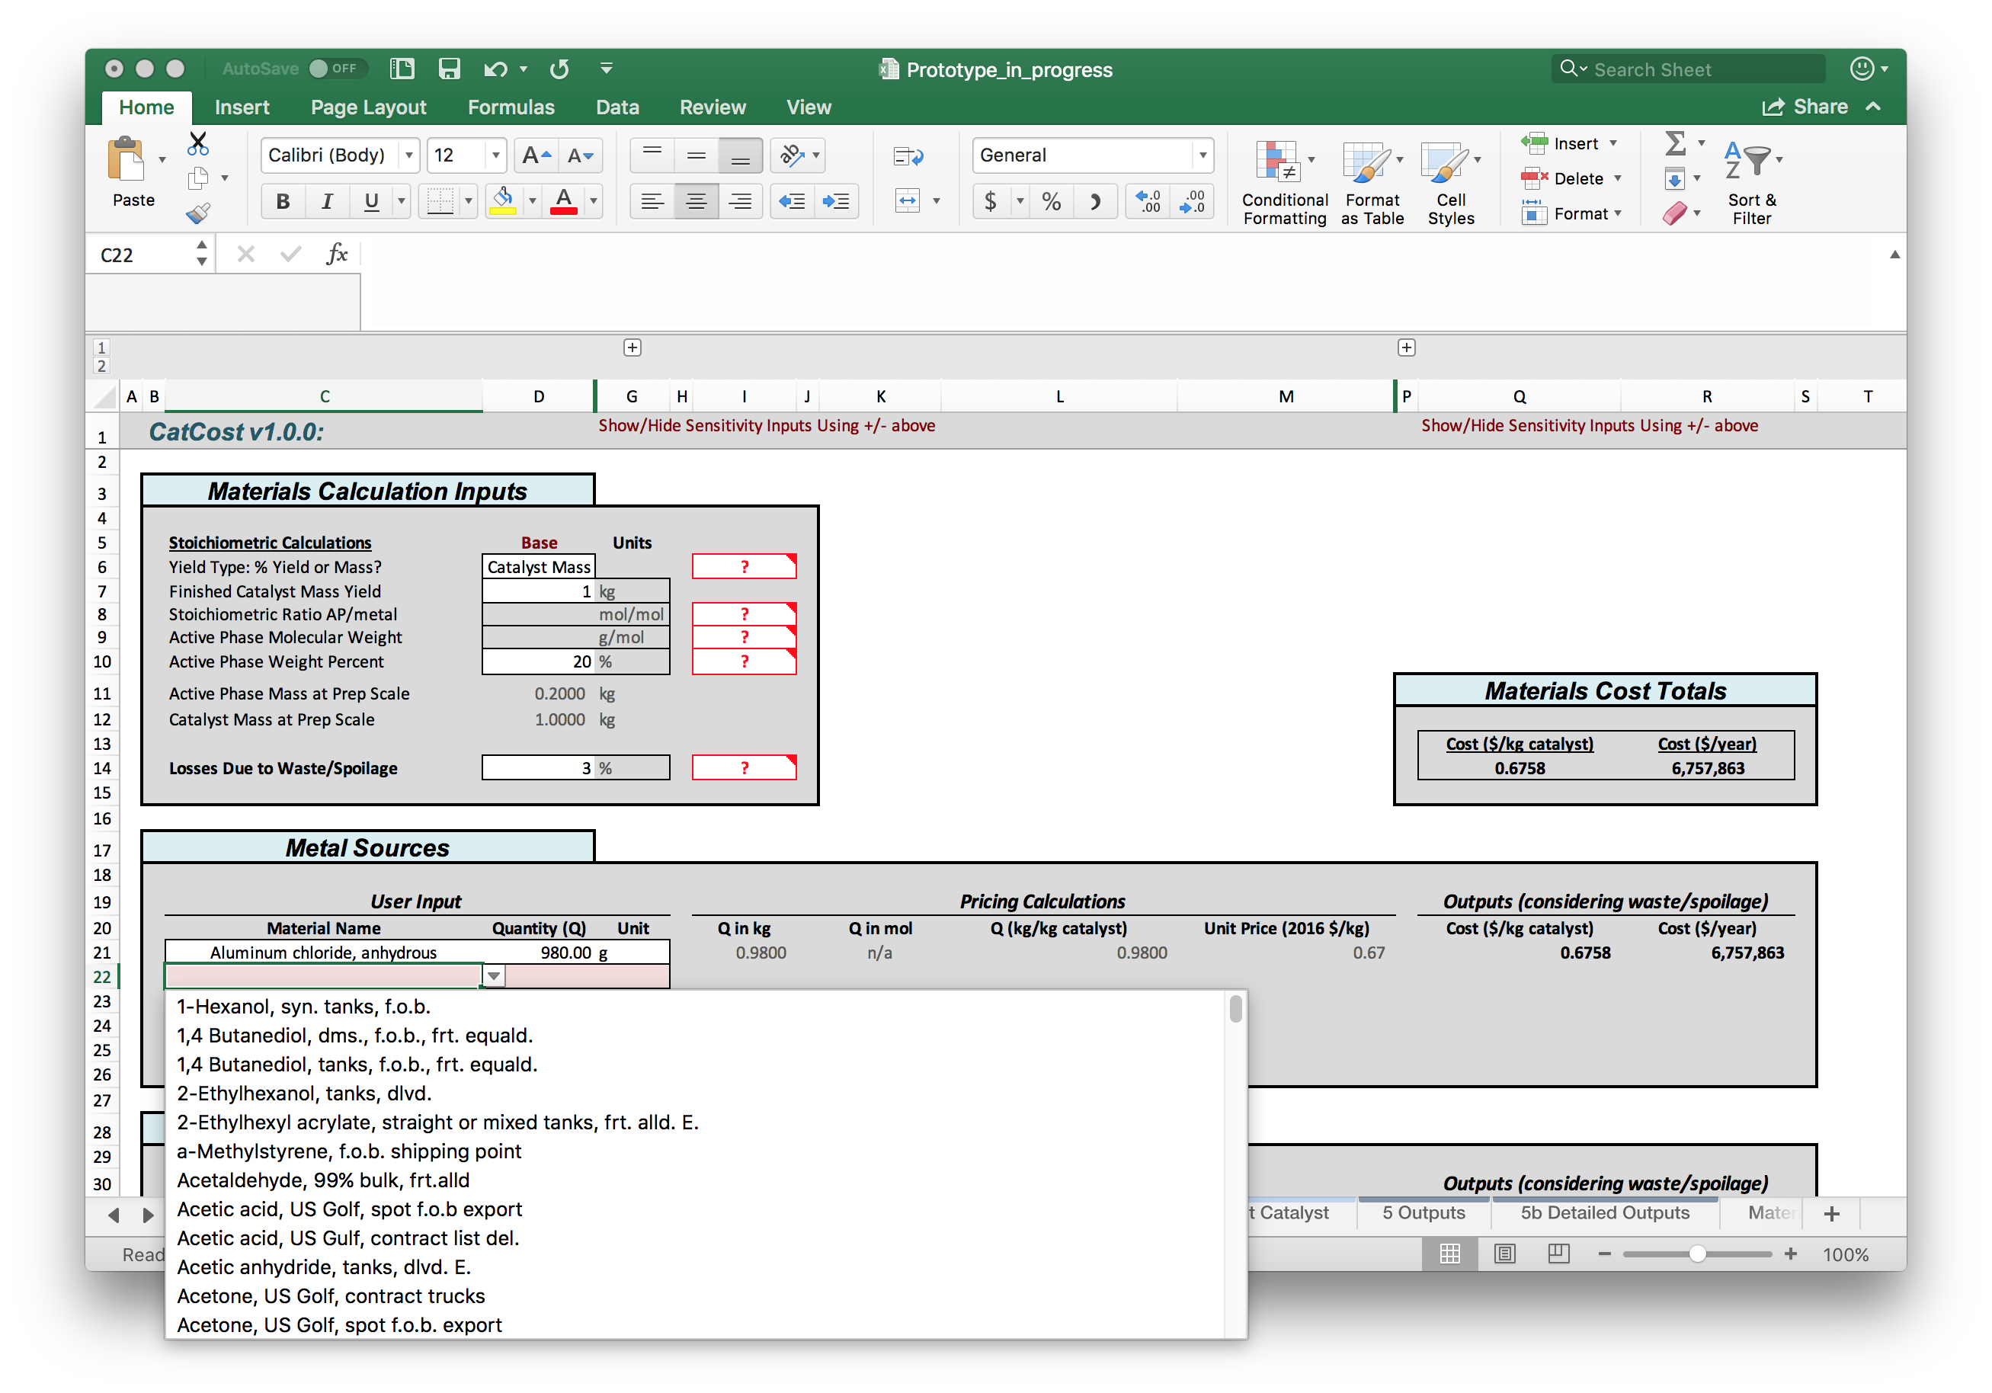

Figure 4.1. The “2 Materials” module in the Excel version of CatCost, showing the entry of stoichiometric parameters and individual raw materials with automated unit conversions and lookups from the Materials Library.

The user may then proceed to add materials to the estimate by selecting an empty cell in the “Material Name” column of “Metal Sources,” “Supports,” or “Other Materials” and using the dropdown button to select a material from the Materials Library. The user then enters a consumption for that material by typing both a quantity and a unit, which will automatically be converted to the estimate mass units. If a volume unit is entered but the Materials Library does not contain a density for that material, the calculation will fail with a “No Density” message. For the user’s convenience, the quantity for the first entry in the Supports table is pre-populated with a formula that calculates the required quantity of a single support to achieve the specified weight loading. This can be overwritten by the user.

The Materials Library of CatCost includes a large library of high-volume chemicals obtained from the ICIS Indicative Price Library. The Materials Library is designed to allow users to easily add new materials by adding a row to the table. Input fields in the Materials Library include the following (see notes in *italic text*):

* Material Name
* Material Type – *used for record-keeping only at present*
* Molecular Weight (MW), g/mol – *used in stoichiometry calculations on “2 Materials”*
* Density (g/mL) – *used for unit conversions on “2 Materials”*
* Concentration (%) – *for record-keeping only at present*
* Lab-Scale Log Fit? – *if “Lab” is selected, a lab-scale log fit is performed*
* Lab-Scale Columns – *show/hide using +/– at top*
  + Lab Quantity 1–4 – *must use same units, entered in “Lab Units”*
  + Lab Units
  + Lab Price 1–4 – *this is a total price, i.e., the price for the quantity of the material specified in the corresponding Lab Quantity column, not a unit price*
* Bulk Quote Price
* Bulk Quote Quantity
* Bulk Quote Units
* Quote Year – *used for price escalation to the estimate basis year*
* Quote Source
* Quote Access Date – *used for record-keeping only*
* Notes

Making selections and entries in these fields allows the Materials Library to automatically perform unit and price calculations. Users are encouraged to add their own materials to the library and to consider keeping their own “master copy” of CatCost with a library of materials appropriate to their estimates. For more details on the calculations performed by CatCost in “2 Materials” and the Materials Library, see the following sections.

## Materials Consumption

Materials consumption calculations in CatCost rely on information from the pre-commercial or lab-scale synthesis of the catalyst of interest. The user supplies the lab-scale quantity of each reagent.

This laboratory-scale reaction stoichiometry serves as the basis of a materials balance and is scaled by CatCost to user-specified quantities. CatCost employs information about the yield and stoichiometry of the synthesis of interest to determine the scaling factor required to convert the user-input lab-scale quantities to the targeted plant design scale in mass units (*Mcat*; capital letters indicate plant design scale). The required information includes the reaction yield (*yield*), the stoichiometric ratio of the active phase to limiting reagent (*molAP/molLR*) in the balanced reaction formula (e.g., synthesis of Mo2C from a reaction-limiting monometallic Mo precursor would have *molAP/molLR* = 0.5), and the molecular weights of both the limiting reagent (*MWLR*) and the catalyst active phase as formulated in the balanced reaction formula (*MWAP*). These inputs allow determination of the active-phase mass at lab scale (*mAP*) (eq .1).

(.1)

The total catalyst mass at lab scale (*mcat*) can then be defined as the sum of the contributions of the active phase (*mAP*) and the support material (*msup*) (eq .2).

(.2)

While the user may supply the mass of support material, if the supporting operation that generates the finished catalyst is assumed to be efficient (100% yield with no discarded support material or active phase), the *msup* can be restrained using the user-input weight percent loading (*wt%*) of active phase in the catalyst (eq .3).

(.3)

The scaling factor (*kSF*) is then defined using the lab-scale (*mcat*) and plant design scale (*Mcat*) catalyst mass quantities (eq .4).

(.4)

Each material’s consumption (in any unit) at lab scale can then be scaled to the plant design scale in the same unit by multiplication with the (unitless or year–1) scaling factor.

## Materials Pricing

When planning catalyst manufacture, the best source for a raw material price is a quote from a credible supplier matching the characteristics of the actual purchase arrangement (e.g., quantity, purity, order frequency, delivery method, and location) most probable for the proposed plant. However, because many of these factors will be uncertain at the time of inquiry and suppliers may be reluctant to undertake the cost of a detailed estimate for a hypothetical purchasing plant that is very early in the design process, such price quotes may be difficult to obtain. Many CatCost users also lack access to in-house price databases used at catalyst companies for cost estimation.

Accordingly, freely available bulk pricing, industry catalog data, and, where necessary, extrapolation from lab-scale supplier pricing, are important for simple and rapid catalyst cost estimates. Among these methods, bulk prices (“bulk” scale is considered to be ≥ one ton) available on marketplace websites such as Alibaba may be useful because they already incorporate the best current market information. However, they may be systematically higher than the final settlement price of a transaction after negotiation.9 When available, proprietary databases like the Process Economics Program (PEP) provided via subscription by IHS Markit Ltd are often useful. CatCost contains freely available prices from the ICIS Chemical Business catalog provided by the RELX Group.10 In general, these databases do not include a comprehensive list of specialty chemicals and are especially lacking in the areas of inorganic and organometallic chemicals. In cases where none of the aforementioned databases provides a credible price, the final two raw materials cost estimation methods, extrapolation from lab scale and in-house synthesis, can be used.

The first method employed for estimation of the cost of raw materials without bulk pricing information is extrapolation from lab-scale pricing. While lab-scale chemical supplier pricing reflects specific investment in that supply scale and order quantity1 and is therefore not ideal for bulk price prediction, it has the advantage of ready availability on supplier websites. Furthermore, previous work by researchers at LBNL9 has established suitable parameters and conditions under which this method provides acceptable accuracy in predicting bulk unit prices.

In the extrapolation method for bulk cost estimation, multiple lab-scale prices are fit to a power function (eq .5) relating the unit price *p* (obtained by dividing the quote price *P* by quote quantity *Q*) to quantity *Q* with two parameters. Using the terminology proposed by the authors of the LBNL report,9 these parameters are the quantity discount factor (*γ*) and scaling parameter (*b*). In practice, fitting is done by log-log linear regression to *p* and *Q* data points, which yields *γ* as the fit slope and *b* as the fit intercept.

(.5)

An example of log-log regression fitting for a common metal precursor is shown in Figure 4.2. A series of price quotes from Acros Organics (through Fisher Scientific)11 for nickel(II) acetate tetrahydrate in quantities ranging from 100 g to 2.5 kg was used to extrapolate the price of bulk Ni(OAc)2•4H2O. The linear regression was performed on log10(*p*) (*p* = *P*/*Q*) vs. log10(*Q*) and produced *γ* = -0.363, *b* = 1.803, and *p*(2,000 lb) = 4.04 $/lb. This calculated bulk price compares favorably to an independently obtained bulk price quote from Alibaba,12 which was not included in the linear regression. The bulk price quote lists $8,250–10,000/tonne for Ni(OAc)2•4H2O, which is equivalent to *p* = 3.74–4.54 $/lb. A plot of *p* vs. *Q* for the lab- and bulk-scale price quotes, including the calculated *p*(*Q*) trendline, is shown in Figure 4.2a. The same information is shown in Figure 4.2b with logarithmic axes, and the details of the calculation are tabulated in Figure 4.2c.

The second method for estimation of raw material costs in the absence of bulk pricing data is an in-house synthesis approach. Without assuming that the raw material would actually be produced in the catalyst synthesis plant through a sub-process, the method of breaking down a raw material into its own synthetic feedstocks and processing steps (using the methods described throughout this section) provides an alternative method of estimation when no other information is available. This approach requires knowledge of likely synthetic routes to the raw material of interest, as well as pricing information for the sub-process inputs. In the case of precious metal salts, it is often a good approximation to simply value the salt using the prevailing price of the metal content, perhaps with a small percentage added to cover the conversion from the most common form of that metal to the desired salt/precursor.

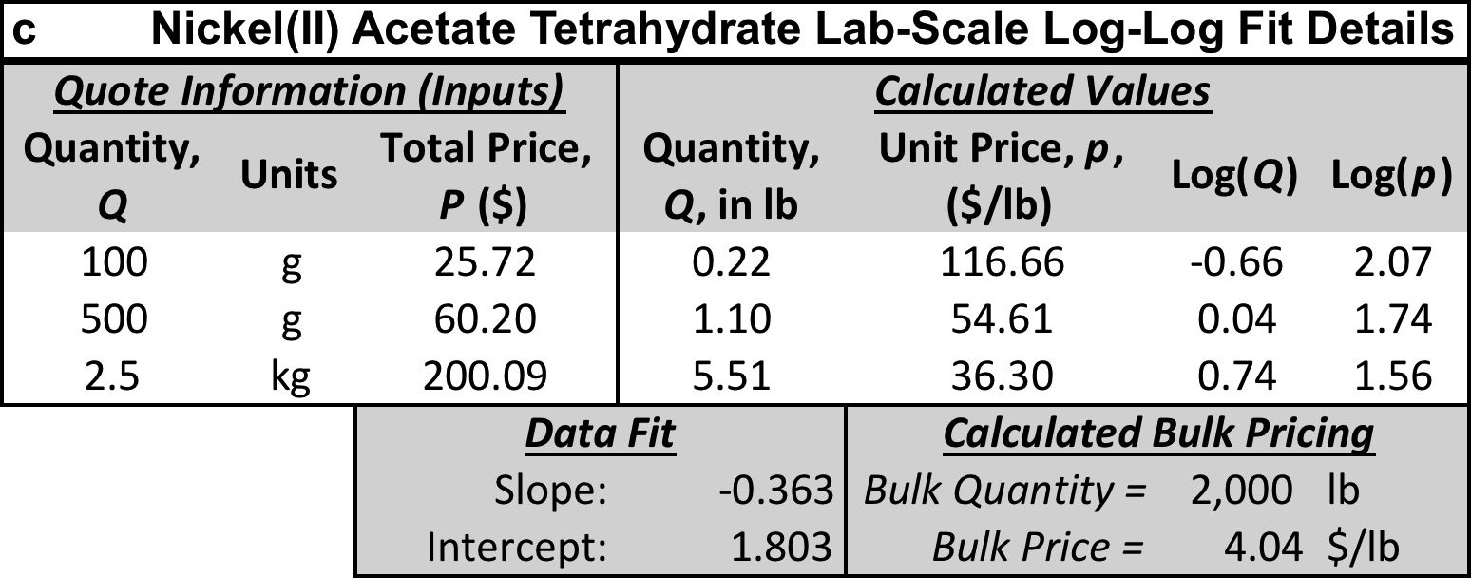

Figure 4.2. Log-log linear regression fit to lab-scale price quote data (2016) for Ni(OAc)2•4H2O: a) plot of *p* vs. *Q* including indicative power fit, b) log-log plot of *p* vs. *Q* including linear regression fit showing agreement with bulk price quote (red), and c) details of price data and linear fit.

# Processing Costs: General Comments and Estimation Parameters on *“1 Inputs”*

## Two Methods for Processing Cost Estimation

CatCost contains two distinct methods for estimating “processing” costs in a catalyst synthesis. Processing costs can be understood to include all non-materials costs of an industrial synthesis, including capital equipment purchase and ongoing maintenance, plant design and construction, land purchase and upkeep, labor, process utilities, and other components of capital and operating costs. Estimating processing costs is the most complex and difficult part of assembling a catalyst cost estimate. In order to provide flexibility to users, CatCost includes two distinct approaches to estimating processing costs. These two approaches, the Step Method and the CapEx & OpEx Factors Method, are summarized below. All estimation methods assume production in the United States with respect to environmental regulations, default entries for regionally varying costs such as operating labor, and other aspects of production.

Step Method *(note: Excel version only in CatCost v1.1.0)*

* Assumes production at a contract catalyst manufacturer (“toller”)
* Uses all-in hourly costs of operation in $/hour
* Requires a list of process steps and an order size in tons
* Based on methods used by tollers to provide price quotes
* Provides rapid estimates
* Modules: “3a Step Method”

CapEx & OpEx Factors Method

* Assumes construction of a new, dedicated catalyst plant for catalyst synthesis
* Uses detailed estimation of “primary” costs and fixed percentages for “secondary” costs
* Requires a list of process equipment including sizes, quantities, materials of construction, and auxiliary equipment such as pumps and motors, as well as process utilities consumption, and a production scale (e.g., kg/year)
* Based on estimating methods from the chemical engineering process design literature
* Provides detailed estimates that require more time and specialized knowledge to prepare
* Modules: “3b Equipment,” “3c Utilities,” “3d CapEx,” and “3e OpEx”

Within CatCost, these two distinct methods are implemented separately as noted in the “Modules” bullets in the list above. When choosing a processing cost estimation method, the user should then complete only those modules listed for that method above. CatCost also allows the user to use both methods in a single estimate, for example using the convenience of the Step Method to evaluate the addition of a single process step to an existing process design assembled in CapEx & OpEx Factors. This is accomplished by the inclusion of a “combined outputs” section in the main CatCost outputs, described below. The two methods could also be completed using similar process steps to allow a comparison between them and thus between the scenarios of toller manufacturing and new-build synthesis plant. ***If combining the two methods (rather than comparing them), it is critical that no process step be entered in both methods, or this will overestimate the cost of producing catalyst (i.e., if a synthesis has 5 steps and steps #4 and #5 are entered in the Step Method, those steps should NOT be entered in CapEx & OpEx Factors).***

Finally, process templates containing all of the necessary inputs for common catalyst types in each method are included in CatCost and described here in Chapter . These templates greatly reduce the time required to prepare an estimate for common catalyst types.

## Processing Cost Estimation Inputs on “1 Inputs”

Processing Cost Estimation Inputs on “1 Inputs” set overall parameters that are used throughout CatCost. The inputs primarily concern the scale of catalyst synthesis in CatCost (). The Step Method Inputs in this module include an order size in tons (values in the range of 1–1000 tons are accepted), which generates outputs including equipment size, synthesis campaign length, and selling margin, as well as the values for several overhead items. The inputs for the CapEx & OpEx Factors method in this module include “Design Production, Annual” and a “Capacity Factor” in % which increases or reduces this value to obtain the “Actual Production, Annual.” Both of these production items have units of catalyst mass per year (e.g., 1 million lb catalyst per year). The difference is that the “Design Production” is what is used to size the catalyst plant for construction, while the “Actual Production” refers to the actual amount of catalyst obtained once the plant begins operation and is used to determine operating costs and the allocation of capital costs. “Operating Hours (Labor)” should generally be set to 8760 hours (24/7 operation) as this sets the operating labor requirements. This indicates that the plant is staffed constantly. However, it is not producing catalyst at all times due to both planned and unplanned downtime, and this is accounted for by the “On-Stream Factor,” which reduces the “Operating Hours (Labor)” to obtain the “Operating Hours, Production,” the number of hours in which catalyst is actually produced. CatCost automatically computes a “Design Production Rate” that is used to scale equipment from a user-entered design or process template to the user’s selection for the estimate’s “Design Production, Annual.” Finally, the user enters a “Plant Life” to allocate capital costs over the entire output of the plant, as well as selecting either a pre-tax return on capital investment, flat margin (% of costs), or both to determine a selling margin for the catalyst. For details on the implications of these inputs, please see the following chapters on processing cost in CatCost.

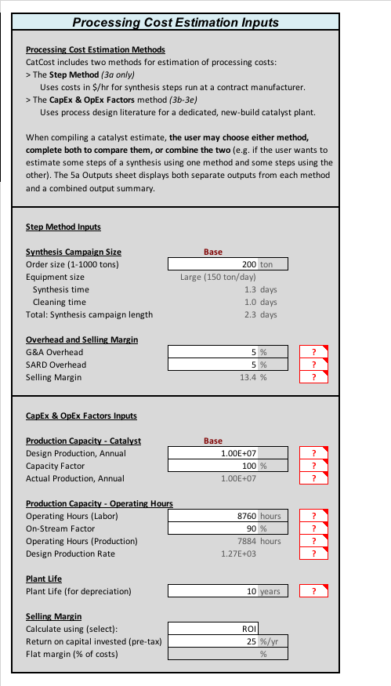

Figure 5.1. Processing Cost Estimation Inputs on “1 Inputs” within CatCost. These inputs primarily concern scale of catalyst synthesis.

# Processing Costs via a Simplified Step Method: The *“3a Step Method”* Module

## Overview and “3a Step Method”

*NOTE: In CatCost v1.1.0, the Step Method is included in the Excel version only. It will be added to the web version in a future release.*

The step method included in CatCost uses a simplified approach to processing cost estimation, in which all capital and operating costs associated with a particular process step (e.g., spray dryer, rotary vacuum filter, extruder) are captured in a single hourly cost at a specified production scale. This includes ancillary equipment for a process unit, such as pumps and motors. This approach is both attractive in its simplicity and highly relevant to real industrial conditions, as it is based on the procedures used by contract manufacturers of catalysts to provide price quotes for their services. The step method assumes that existing process equipment at a contract manufacturer (toller) is used to produce the catalyst, in contrast to the CapEx & OpEx Factors Method described later. The step method can be used on its own to assemble a complete synthesis process in CatCost, or as a way to rapidly add a step to an existing process design in the CapEx and OpEx Factors Method.

The “3a Step Method” module is quite simple. The user can choose a process template from a list of over 10 (described in Chapter ) or enter a custom process. If entering a custom process or editing a process template, the user simply selects process steps from the available list. Some process steps will not be available at the synthesis scale (Small, Medium, or Large) that has automatically been chosen for the user-entered order size on “1 Inputs”; CatCost will suggest an alternate step in those cases. For each step, the tool will then automatically look up the correct hourly cost for each step and compute the campaign cost and cost per unit of catalyst. For more details on the basis for the Step Method, see the following sections or read the full publication.13

## Background

The production costs for a novel catalyst may be estimated rapidly using a step-based method in which individual processing steps, corresponding to specific process equipment used by a contract manufacturer of catalysts, are selected from an established list. This estimation method and the names and costs of individual steps are based upon those used by contract catalyst manufacturers to provide price quotes for their paid manufacturing services. Each step corresponds to a process equipment unit at a particular scale and includes all capital and operating costs, such as equipment purchase, maintenance, operating labor, and utilities. A step-based approach to estimating the cost of catalyst manufacture enables researchers with minimal process design experience to successfully execute an estimate using an appropriate list of process equipment units that approximate a laboratory-scale synthesis.

For example, consider a synthetic chemist who has developed an improved catalyst synthesis that is based on an existing process, but requires an additional reaction step that has been successfully executed at the laboratory scale in a small autoclave. Determining the cost of the new process at industrial scale including this additional step would previously have required working with an engineer who can properly size the reactor for large-scale production and price any new materials needed. The engineer would determine the cost to operate this reactor in an existing plant of appropriate size and provide the chemist the cost of new materials and the new production step (e.g., $0.10/kg product). The researchers then determine whether the improved quality/performance or yield of catalyst achieved by adding this step is justified and, if so, proceed with developing a proposal for management approval. The step method detailed herein simplifies this process by providing a pre-determined list of common process steps for catalyst order quantities in the range of 1–1000 tons. This method can then be used by a researcher or team that does not have access to process design expertise, or with greater speed and accuracy by a team that does.

## Preparing a Step Method Estimate

### Inputs

A price estimate using the step method requires information on both the catalyst synthesis (Synthesis Inputs) and the market or application it will be used in (Business Inputs), as shown in Figure 6.1. This discussion will begin with Synthesis Inputs, which are based on a lab-scale synthetic procedure developed by the researcher or obtained from the literature.14

The step method presented herein relies on the assumption that the synthetic procedure translates readily into steps that are well known by the catalyst manufacturing industry.

### Synthesis Inputs

The Synthesis Inputs include catalyst composition and preparation stoichiometry, raw materials consumption and pricing, and synthetic steps. Composition, preparation stoichiometry, and materials pricing are obtained as described above. Finally, the selection of industrially relevant process steps using the step method is conducted to complete the cost estimation.



Figure 6.1. Flow of information in the step method from inputs to an estimated price.

The laboratory-scale synthetic procedure to prepare the catalyst serves as the basis for translation into industrially relevant process steps. A list of process steps and associated hourly costs for process equipment units commonly used in commercial catalyst synthesis is provided in . A user of the step method begins by selecting steps from this list that correspond to the synthesis steps used for their material at lab scale. Price estimates for three catalysts including Pt/C, Ni/Al2O3, and a modern fluid catalytic cracking (FCC) catalyst based on ultrastable zeolite Y (USY) were assembled using steps from and are discussed below as part of the validation of the step method.

Table 6.1. Synthesis steps and hourly costs available in the step method.*a*

|  |  |  |  |  |
| --- | --- | --- | --- | --- |
| **Step Name** | **Costs ($/hour)*b*** | | | **Substitute Step*c*** |
|  | Small (1 t/d) | Medium (10 t/d) | Large (150 t/d) |  |
| Ball forming | 100 | 150 | — |  |
| Crystallizer | 100 | 200 | 300 |  |
| Dryer, batch vacuum tray | 50 | — | — | Rotary dryer |
| Dryer, rotary (40–100 °C) | 75 | 100 | 200 |  |
| Dryer, rotary (100–300 °C) | 100 | 150 | 300 |  |
| Dryer, spray | — | 300 | 550 | Rotary dryer |
| Extruder, with feeder | 100 | 200 | 425 |  |
| Filter, belt vacuum | 125 | 175 | 400 |  |
| Filter, plate and frame | 75 | — | — | Belt/rotary vacuum filter |
| Filter, rotary vacuum | — | 100 | 300 | Plate and frame filter |
| Flare | 50 | 75 | 150 |  |
| Incipient wetness (impregnation) | 75 | 100 | 200 |  |
| Kiln, batch (300–1290 °C) | 75 | — | — | Continuous kiln |
| Kiln, continuous direct (300–1290 °C) | — | 225 | 400 | Batch kiln |
| Kiln, continuous indirect (300–1290 °C) | — | 175 | 325 | Batch kiln |
| Mill | 50 | 100 | 200 |  |
| Mixer, dry blender | 50 | 100 | 200 |  |
| Mixer, slurry | 75 | 100 | 200 |  |
| Reactor, simple (mixing) | 30 | 60 | 200 |  |
| Reactor, multistep | 100 | 175 | 600 |  |
| Scrubber, NO*x* | 35 | 75 | 200 |  |
| *a*Costs use a mid-2017 basis in the United States. *b*Hourly costs of operation ($/hour) for process equipment at small, medium, and large scale. Cleaning costs have the same hourly rate as operation. Dashes indicate that that step / process equipment unit is not commonly used at the specified scale; see substitute column for suggested alternative. These costs assume a 24-hour day. *c*For synthesis scale(s) at which that step is unavailable, indicated by a dash. | | | | |
|  | | | | |

### Business Inputs

For an accurate estimate, the Synthesis Inputs must be coupled with Business Inputs that consider the effect on price of intended catalyst use. The key business input to the step method is order size, which depends on knowledge of the catalytic application including catalyst charge, lifetime, order frequency, and any other factor affecting catalyst demand. In this way, the accuracy of the step method depends on testing15 and technoeconomic analysis information on the catalyst and its application. In general, an economically viable catalyst will have a lifetime of at least 6–12 months, but because it is common practice to run multiple reactors in parallel and stagger catalyst replacement, the catalyst order frequency may not be equivalent to catalyst lifetime. A typical non-precious metal containing catalyst would be ordered twice per year. Catalysts containing gold, silver, or a platinum group metal (PGM) are typically ordered four times per year to minimize the cost of on-site and in-the-loop catalyst inventory.16 From all this information the order size and frequency can be determined for the catalyst of interest. If ordering the catalyst from a contract manufacturer, the customer would provide this order size and frequency to the contract manufacturer or toller, who would then develop a price quote for a synthesis “campaign” to produce each order. In the step method described here, only the order size, in the range of 1–1000 tons, is needed to determine a price.

A step size (in tons/day) and campaign length can then be determined based on the desired order size. Determining the campaign length starts with selecting a synthesis scale, because a contract manufacturer has existing equipment at specific scales to choose from. These scales are defined here as Small (1 ton/day), Medium (10 tons/day), and Large (150 tons/day). The Small scale is used for 1–5 ton orders, the Medium scale for 5–70 ton orders, and the Large scale for 70–1000 ton orders. Determining the campaign length is then as simple as dividing the order size (tons) by the appropriate production scale (tons/day) and adding time for cleaning (0.5 days for Small; 1 day for Medium/Large). Standard protocol in the industry dictates that equipment is clean at the start and end of each campaign. Cleaning time is charged at the same rate as operating time because the requirements (operators, utilities, etc.) are similar. This entire process is depicted graphically in .

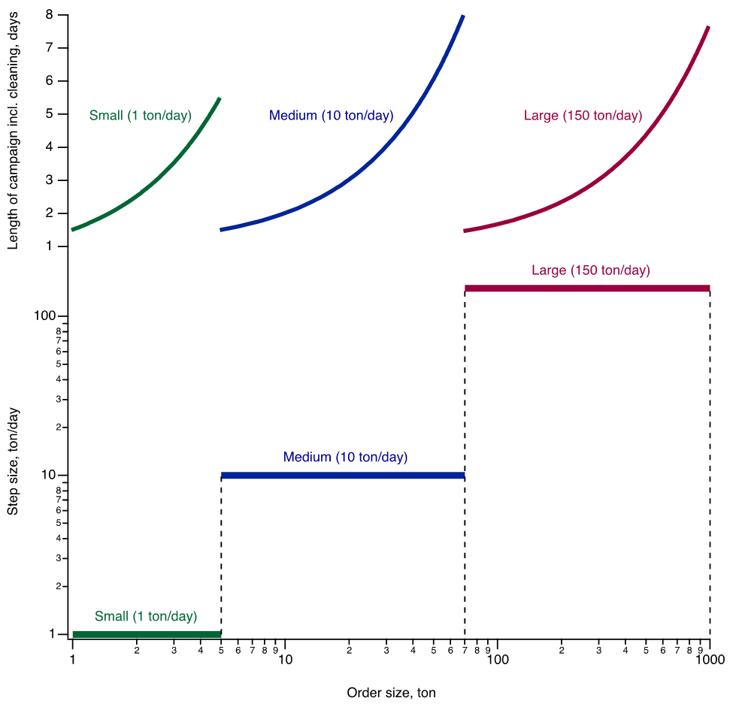

Figure 6.2. Step size (bottom, ton/day) and campaign length including cleaning (top, days) as a function of order size (tons), assuming 24-hour operation. Cleaning time is 0.5 days for Small and 1 day for Medium/Large.

### Total Campaign Cost, Overhead, and Selling Margin

Having determined the production scale and campaign length, the hourly production cost is then calculated. Using the list of steps selected from at the appropriate production scale (Small, Medium, or Large), the corresponding hourly costs are then added to determine a total hourly operating cost for the entire process. The costs in are inclusive of all operating and capital costs including operating labor, maintenance, utilities, etc., and were determined through discussions with industry experts as well as literature review.17 The costs have a mid-2017 basis assuming production in the United States. For escalation of these costs to other estimate basis years, the “ChemPPI” library is used. Note that because all the process equipment used in a synthesis is devoted to that customer’s order throughout the campaign including cleaning, the hourly cost is constant for each unit/step. For steps in that are not available at a particular production scale (e.g., a spray dryer at small scale), the alternative step suggested in the Substitute column may be selected instead. Using a 24-hour day, the daily production cost can then be calculated and multiplied by the campaign length in days to determine a total production cost for the next step in the catalyst price estimation process.

The final step of developing a catalyst price estimate using the step method is to add overhead costs and a selling margin. The raw materials and synthesis step costs are first added together as a subtotal. Then General and Administrative (G&A) costs are calculated as 5% of this subtotal, and Sales, Administrative, Research and Distribution (SARD) of 5% of both the subtotal and G&A.4,8 Note that distribution entails loading the product on a dock at the catalyst production site; the customer pays the freight. For the purposes of a step method estimate, the selling margin can be considered solely as a function of the order size. In the corresponding author’s experience with commercial catalyst manufacture, a single relationship between the selling margin and order size applies to a large majority of catalyst types, including but not limited to supported PGM, supported base metals, and metal oxides. As the order size increases, the margin decreases from ca. 33% of the selling price (50% of pre-margin costs) at the 2-ton scale to ca. 8% of the selling price at the 1000-ton scale, following a linear relationship between the logarithms of order size and margin (). Note that the raw materials costs are generally included in the overhead and selling margin calculations because the contract manufacturer assumes the expense and risk of procuring the raw materials to meet the specifications and timeline of the catalyst purchaser. However, the costs of any noble metals would be excluded from the overhead and margin because they are provided by the catalyst user’s pool account or offset by recoverable metals content.16



Figure 6.3. Selling margin (% of selling price) as a function of order size (ton).

## Step Method Demonstration and Verification with Market Price Data

### Catalyst Price Assessment: Pt/C

Using the procedures described in the previous section, the following example demonstrates the execution of the step method to estimate the price of a 2 wt. % Pt/C catalyst. This estimate uses the assumption of a precious metals pool account that is managed separately,16 so the value of platinum content is excluded.

As described in the Synthesis Inputs section, the first step to estimating the price of the Pt/C catalyst is to determine the raw material requirements, catalyst composition, and synthesis method from the laboratory-scale procedure. In this example case, a researcher seeks to estimate the price of a 2 wt. % Pt/C catalyst that is prepared by wet impregnation of an activated carbon support with chloroplatinic acid (H2PtCl6). The price for the chloroplatinic acid does not include the value of Pt; it includes only the price of converting Pt metal to H2PtCl6 via oxidation in *aqua regia* because of the pool account assumption mentioned above. In this procedure, a slurry of the Pt precursor and carbon is chemically reduced by the addition of hydrazine (N2H4) at 50 °C. Because the reaction liberates HCl upon reduction, the reaction vessel is fitted with a sodium hydroxide scrubber. The Pt/C material is then filtered and dried at 90–­95 °C to remove 50% of the moisture and yield the final catalyst. This procedure was used to populate the raw materials requirements (lb/lb catalyst) shown in . Based on the lab-scale procedure, the industrial-scale process equipment units selected from include incipient wetness, multistep reactor, scrubber, plate and frame filter, simple reactor, and rotary dryer (40–100 °C).

Proceeding to Business Inputs, the envisioned application of the Pt/C catalyst is a large-scale slurry hydrogenation plant with a hypothetical 8 ton/year catalyst demand. In order to minimize the value of Pt in the precious metals loop (i.e., to reduce inventory),16 an order frequency of 4 orders per year was assumed, giving an order size of 2 tons. Using this order size and the relationships illustrated in , the Small (1 ton/day) scale was selected and the campaign length was determined as 2.5 days, including cleaning. A total campaign cost ($23,400/campaign), not including materials, overhead, or margin, was then calculated by multiplying the step cost total ($390/hr, $9360/day) from by the campaign length (2.5 days).

Adding the raw materials and synthesis campaign costs gives a subtotal of $16.55/lb catalyst, as shown in . The final step of developing a catalyst price estimate using the step method is to add overhead costs and a selling margin. As described above, G&A (5% of subtotal), SARD (5% of [subtotal + G&A]), and selling margin (50% of [subtotal + G&A + SARD] at the 2 ton scale) are added to yield an estimated selling price of $27.37/lb for this Pt/C catalyst.

### Comparison of Three Step Method Catalyst Estimates to Market Prices

Following the procedures outlined in the previous section for 2 wt. % Pt/C, price estimates were developed for 21 wt. % Ni/Al2O3 (at 20-ton scale) and a USY-based FCC catalyst with rare earth content (at 200-ton scale). The Ni/Al2O3 order size was based on a fixed bed reactor (catalyst charge of 10 tons) with an expected catalyst life of 6–12 months; this first order is intended to fill the reactor and have a spare charge. The FCC catalyst order size was based on 5 ton/day catalyst feed rate at a typical refinery, with 100 days of inventory. The components of these estimates are shown in along with the Pt/C estimate. The step method-based estimates using the mid-2017 step costs for the three materials compare favorably with market price data,18 also from mid-2017 in the US, within ± 20% relative to the market prices.

Table 6.2. Step method examples using a mid-2017 cost basis: Pt/C, Ni/Al2O3, and USY-based FCC catalysts.





# Processing Costs via a Detailed CapEx & OpEx Factors Method: The *“3b Equipment,” “3c Utilities,” “3d CapEx,”* and *“3e OpEx”* Modules and *Equipment Library*

## Overview

The second approach to processing cost in CatCost is a detailed, factored processing cost estimation method, entitled CapEx & OpEx Factors. This approach, in contrast to the step method described in the previous chapter, assumes the construction of a dedicated process plant to synthesize the catalyst in question. The CapEx & OpEx Factors method allows significantly more detail and potentially more targeted insight than the step method, but requires more time and specialized knowledge/tools (e.g., AspenPlus) to generate. However, we have reduced these demands dramatically for common catalyst types by inclusion of process templates (Chapter ).

The potential accuracy and flexibility benefits of a factored processing cost estimate result from the explicit consideration of a wide range of capital and operating components of processing cost. The methods for inclusion in CatCost were identified primarily through review of the process design literature used by chemical engineers for cost estimation. The methods selected for inclusion have been extensively used and validated, which means detailed information is available on the accuracy of each method and the associated error of each component for sensitivity analysis.

In this chapter, the methods are presented first and the implementation of these methods in CatCost is found in the last section.

## Simplifying Estimates with Primary and Secondary Categories

In the process design literature, preliminary cost estimates for a new-build chemical synthesis plant are commonly made using a factored approach. This involves estimating a few components, which we will call “primary” costs, in detail and using factors (i.e., percentages) of the primary components to determine the other, “secondary” components.4,6,19-23 The primary components commonly include raw materials purchase cost, direct operating labor cost, and equipment purchase cost. The secondary components comprise a wide variety of costs, such as ongoing supervisory labor or capital cost for piping, that tend to vary linearly with a particular primary component, within a known range. The accuracy afforded by this approach is on the order of ± 15 % up to ± 40 % (commonly called “preliminary” or “study-grade” in design literature),5,6 which is appropriate for inclusion in CatCost.

Following this literature precedent, the procedure for estimating a catalyst cost using CatCost can be defined by three steps: (1) From the lab-scale synthesis procedure, develop a list of unit operations (e.g., jacketed, agitated reactor, spray dryer, ball mill) needed to conduct the synthesis at industrial scale. (2) Using the list of operations and the synthesis information, price primary components such as raw materials purchase cost, delivered-equipment purchase cost, ongoing direct labor, etc. (3) For secondary costs that vary directly with one of the primary outputs, use a factor (i.e., a percentage) to determine those costs from the primary output. This concept is depicted in , which shows secondary components of capital cost being determined as factors of the primary component, purchased equipment cost.



Figure 7.1. Illustration of the concept of determining secondary cost components as factors (percentages) of primary cost components, such as delivered purchased-equipment cost, that are first calculated in detail.

## Determining Primary Costs: Capital

Capital cost estimation for process plants begins with pricing each unit of process equipment. Equipment purchase cost is widely estimated by scaling a known price for a similar piece of equipment to the specific size needed in a process.4,19-23 Rather than scaling linearly, these prices tend to follow power-law relationships (eq .1) with 0.6 being a common value for exponent *a*. The specific exponents to use for various pieces of equipment have been tabulated most extensively by Garrett and range from 0.38 to 0.90.24 This method therefore requires only a valid price quote for each equipment type. For scaling purposes, the size of equipment is typically measured by a flowrate, heat-transfer area, volume, power rating, etc. Some authors have improved the accuracy of the scaling method by incorporating more than one parameter for a particular equipment type.8,22,25 For example, Ulrich and Vasudevan scale process vessels not by volume alone, but as a function of both height and width to account for the relatively larger material requirements of extreme shapes.22 It is also common to include factors for the cost of various materials of construction, e.g., carbon steel, stainless steel, aluminum. Importantly, some authors also include an exemplary price quote for each equipment type,19,24 allowing complete algebraic determination of equipment cost at arbitrary size (within the extrapolation limits of these methods), which is what is needed for incorporation into CatCost.

(.1)

A number of these equipment pricing methods have been compiled into web- or spreadsheet-based costing tools, most of which also facilitate the calculation of secondary costs (buildings, piping, installation, etc.) based on purchased-equipment cost. A useful review of these pricing tools has been published by Feng and Rangaiah.25 Thus, there is precedent for the type of equipment costing used in CatCost.

CatCost includes a library of equipment cost correlations to allow the expert user to develop an equipment list and associated capital cost estimate from scratch. This library also forms the basis of the process templates (next chapter) so that users without design experience will be able to simply select a catalyst synthesis type, such as wet impregnation, zeolite, metal-organic framework, etc. and have the equipment list auto-populated. Equipment cost correlations in the Equipment Library take one of two forms: a power-law form (eq .2) derived from eq .1 or a poly-exponent form (eq .3),8 in which a, b, c, d, e, and n are constants used to fit empirical cost data and *S* is a sizing input parameter, such as volumetric capacity in gallons.

(.2)

(.3)

## Determining Primary Costs: Operating

Direct labor cost is the most common primary component of operating costs in published estimation methods.4,22,23 Direct labor is defined here as the sum of labor requirements of each process unit. Items like supervisory labor and laboratory / quality assurance are figured as factors of direct labor. Direct labor can be readily calculated for a particular piece of process equipment *i* using the formula in eq .4. The (Operator Hours / Equipment Hours)*i* variable represents direct labor requirements for that piece of equipment; a value of 1.0 would indicate one full-time operator per process unit; a value of 0.5 would indicate an operator splitting his/her time between two units of this type. The local productivity adjusts the operator/equipment ratio to local labor productivity figures, which vary regionally. Both of these values are available in chemical engineering design texts.4,22,23 The local hourly labor rate can be freely obtained from the U.S. Bureau of Labor Statistics or corresponding bodies abroad.

(.4)

## Determining Secondary Costs with Factors

The third and final step of processing cost estimation, determination of factored or secondary costs, is applied to capital costs using the equipment costs as primary components. This general approach was first described by Lang,26,27 who proposed that the total capital cost of a process plant could be estimated as between 3.10 and 4.74 × the total purchase cost of the major equipment items. The disadvantage of this approach is that it is not very accurate or process-specific. Progress was made by Hand28 and later by Guthrie,19 who proposed different factors for each type of equipment. These were called “module factors” by Guthrie because they give the total installed cost, including materials and labor, of the entire process unit (i.e., the module) relative to the equipment purchase price alone. These methods make the overall estimate more process-specific and therefore more accurate but are not very complete in terms of equipment types covered. Garrett, on the other hand, provided a set of both module factors and installation factors (similar to the module factors but omitting related minor equipment and piping) for a wide range of equipment types.24 We found Garrett’s set of installation costs to be the most comprehensive single set of numbers, to agree generally with the variation in installation costs for different equipment types provided by other equipment-specific sources,19,22,28 and to fall within the range (when used within exemplary catalyst estimates) established by Lang-type methods4,26,27 for the components covered. Separately, Peters and Timmerhaus updated the original Lang approach to provide a breakdown for an overall process plant, including direct capital costs like installation, piping, instrumentation, and buildings; indirect costs like engineering, legal, and contingencies; and working capital.4 However, like the original Lang factors, the Peters and Timmerhaus method does not account for the specific types of equipment included in the plant. In CatCost, we have implemented a hybrid approach that achieves process specificity by using the equipment-specific installation factors of Garrett,24 while using the factors of Peters and Timmerhaus4 for all other components of capital cost. This approach allows the user to see how much, for example, installation labor or equipment insulation contributes to product cost.4,22,23 This concept is depicted in and exemplary factors from two references are shown in Table 7.1. The table displays the slight variation in categories and factor values that is common in the literature. Furthermore, the user can customize the ranges used in the estimation to improve the usefulness of the sensitivity information this method provides.

|  |  |  |
| --- | --- | --- |
| **Table 7.1.** Determination of secondary cost components from primary components in plant capital cost estimation: exemplary factors from literature. | | |
| **Capital Cost Factors**  Delivered Purchased-Equipment  Installation  Instrumentation and Controls  Piping (installed)  Electrical (installed)  Buildings  Yard Improvements  Service Facilities  Engineering and Supervision  Construction Fees  Contingency  **Total Fixed Capital**  Working Capital  **Total Capital Investment** | **Factor – ref. 4 (%)**  100*a*  39–47  18–36  16–68*b*  10–11  18–25  10–15  40–70  32–33  34–41  35–44  **397–504**  70–89  **467–593***c* | **Factor – ref. 23 (%)**  100*a*  30–60  20–30  20–80  15–20  15–30  20–30  30–40  20–30  not included*d*  30  **455–605**  not included*d*  **455–605** |
| *a* By definition.  *b* There are more detailed, but still deterministic, methods for accurately estimating components that tend to vary widely, like piping costs. *c* Since working capital is recovered at the end of the plant lifetime (though this inflow must be discounted), including it here gives the total upfront capital cost. *d* These categories from reference 4 are grouped into other categories in reference 23. | | |

For estimation of secondary components in operating costs, direct labor is the most common basis (e.g., for items like laboratory costs and benefits) but other bases are also important. For example, total capital cost is among the best predictors for items like maintenance costs and certain utilities. Some items, such as energy costs, rely on equipment-specific requirements and modeling the local cost of energy commodities.

For each of the secondary cost categories, CatCost provides situation-dependent low, average, and high values for the determining factor. These values represent a synthesis and update of the various literature references to guide user input and form the basis of future sensitivity analyses. These values are intended to be a starting point for users to adjust and learn about the effect of these factors on their catalyst cost estimates.

## Implementation in CatCost

The processing cost methods described above were incorporated into a functional, extensible, and user-friendly CapEx & OpEx Factors method within CatCost. This method allows detailed and accurate cost estimations while automating much of the process to reduce the time required to generate an estimate.

### The “3b Equipment” Module and Equipment Library

The foundation of the CapEx & OpEx Factors method in CatCost is the equipment list for the industrial catalyst synthesis process, found in module “3b Equipment.” This equipment list generates or influences the majority of capital and operating cost components in CatCost and corresponds naturally to the process steps a catalyst engineer is accustomed to designing. The equipment module for a particular process template (see chapter for details on process templates) is shown in . It contains a section with template info and scaling inputs (A), the main equipment list where equipment items are selected and sized (B), a section where equipment items are automatically scaled to the estimate production scale and costs generated (C), and cost and labor factor totals (D).

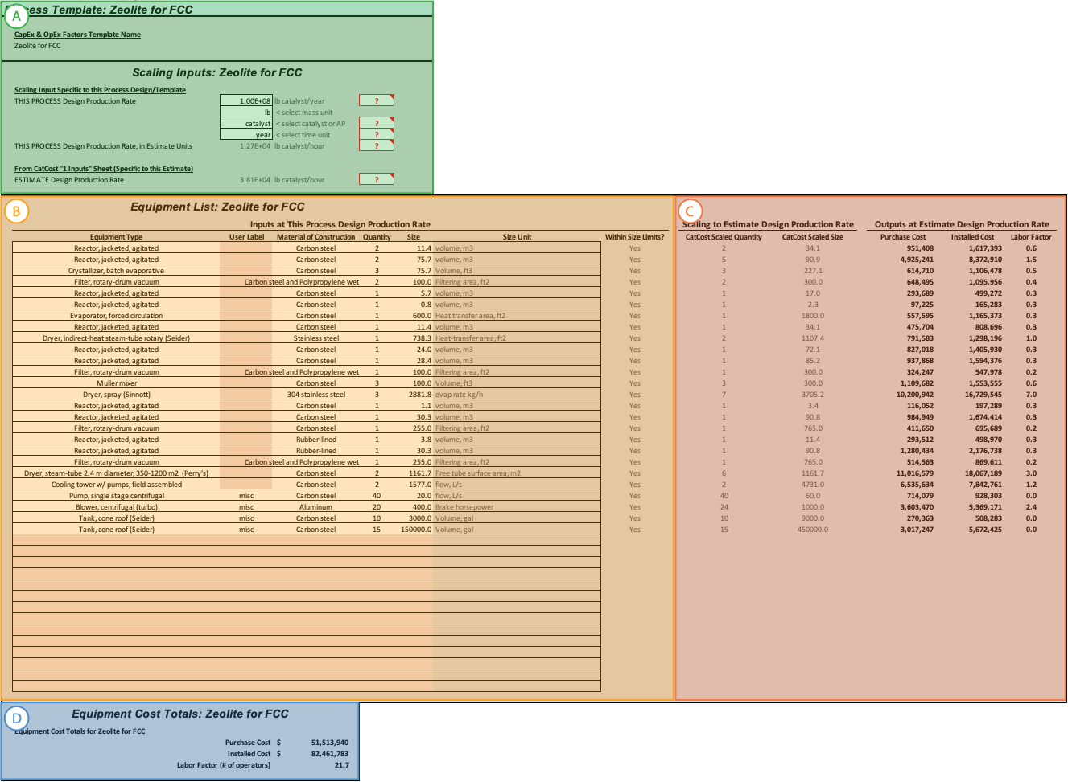

Figure 7.2. The equipment list module for the Zeolite for FCC process template, showing the four sections: A) Template info and scaling inputs, B) equipment list with equipment selection and sizing inputs, C) automated scaling to estimate production rate, and D) totals section.

In the scaling section (A & ), inputs on the throughput of the equipment list specified in the equipment selection and sizing inputs section (B) are entered. This information is analogous to that in the Materials Calculation Inputs section of “2 Materials.” The information entered in “THIS PROCESS Design Production Rate” tells CatCost the catalyst production throughput of the process represented by the equipment list in B. Separately, the “ESTIMATE Design Production Rate” is looked up from “1 Inputs.” As a result, the user is able to change the Design Production Rate on “1 Inputs” and this will cause CatCost to automatically scale the entered equipment list from the scale of “THIS PROCESS Design Production Rate” to the scale of “ESTIMATE Design Production Rate.” See below for details on scaling.

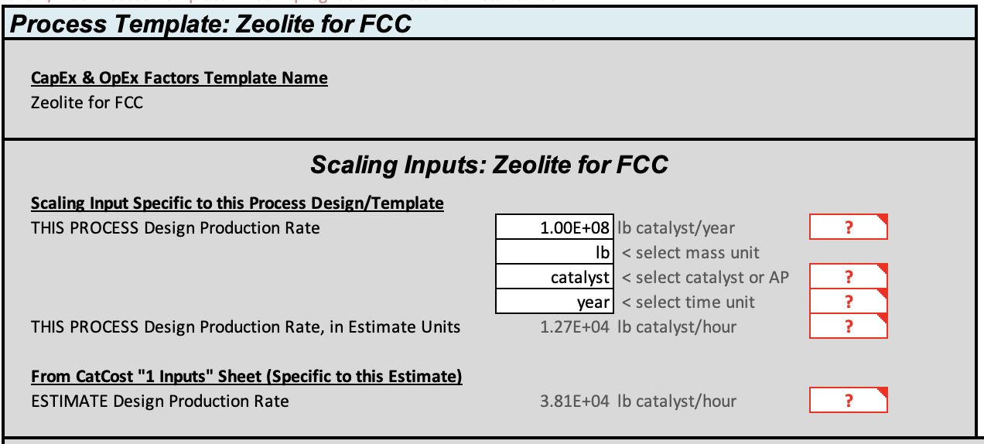

Figure 7.3. The template info and scaling inputs section of the equipment module.

In the main equipment list section (B & ), users select process equipment (such as ‘Reactor, jacketed, agitated’) from the CatCost Equipment Library, which we believe to be the largest free and publicly available library of costs for chemical process units. It contains over 200 pieces of equipment from respected sources.4,8,19,22-24 Equipment items are added by drop-down, as in “2 Materials.” For equipment added to the list, CatCost prompts the user for a sizing parameter, such as tank size in m3 or pump power in kW. It also allows the user to select the material of construction for each piece of equipment according to process requirements, such as corrosion resistance. The material of construction selection causes CatCost to multiply that equipment item’s by a material factor. For each equipment item, there is a base factor (e.g., carbon steel = 1.0) and other materials are relative to it (e.g., 316 stainless = 1.3; Hastelloy C = 1.55). The available materials depend on the equipment item.

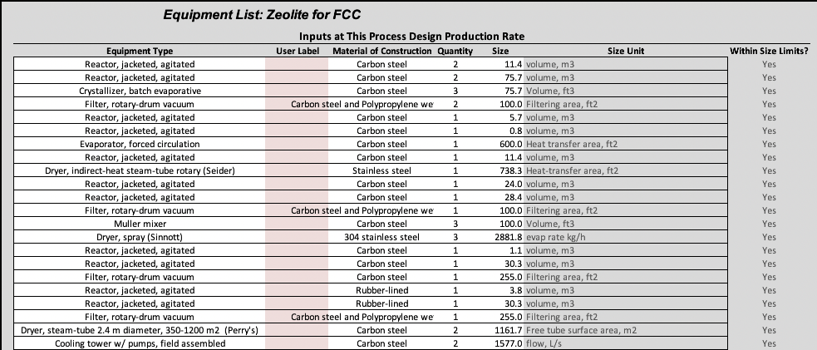

Figure 7.4. The main equipment list section for a Zeolite for FCC process design, showing Equipment Type selection from the Equipment Library by dropdown list, User Label, Material of Construction, and the scaling inputs Quantity and Size. Note that the Size Unit from the Equipment Library is provided and varies between equipment items. Finally, a “Within Size Limits?” check is included to help users identify when their process design might be better suited by an alternate equipment type (the equipment will still be scaled automatically by CatCost even if outside the size limits range).

Based on the user inputs to the equipment list, CatCost automatically looks up and calculates key outputs for each equipment item and for the process plant as a whole. These outputs include the equipment purchase price, using established cost correlations that incorporate factors for varying materials of construction and which automatically notify the user of equipment which is sized outside the pricing correlation’s range of validity; factors that multiply with the equipment purchase price to produce an installed cost (which includes the equipment and associated fittings, support structures, installation labor, etc.); and direct labor requirements for each piece of equipment ().



Figure 7.5. Screenshot of the main equipment list inputs and scaling outputs sections of the equipment module, showing the automated scaling built into CatCost. The jagged line indicates cells that are hidden. The equipment in the list has automatically been scaled from the reference design scale for this equipment list of 100 M lb/yr to this estimate’s production scale of 300 M lb/yr. The outputs section contains purchase cost, installed cost, and a labor factor. Purchase cost is calculated using material of construction-specific pricing correlations and scaled from the correlation year to the estimate basis year. For each piece of equipment, factors for the number of labor operators and for installation cost as a multiple of purchase price are retrieved from the CatCost database.

Evaluating the effect of changing production scale is easy and automated in CatCost. It automatically adjusts the size of equipment items entered from the scale specified by “THIS PROCESS Design Production Scale” to the “ESTIMATE Design Production Scale” (see for the scaling inputs and Figure 7.5 for the scaling outputs). In Figure 7.5, an example that scales the Zeolite for FCC process from 100 M lb/yr to the estimate scale of 300 M lb/yr is shown. If this scaling sizes a piece of equipment below its pricing correlation’s minimum size, the price of a minimum size unit is used; similarly, if the equipment called for is too large for a pricing correlation, CatCost automatically generates two or more of that piece of equipment to replace the oversized unit, while never using fewer than the number specified in the base case (i.e., if pumps are needed in two locations then at least two pumps are needed). The rest of the logic in the processing module carries these changes through, allowing a user to rapidly see how the fraction of catalyst cost contributed by, for example, capital investment changes with production scale. shows the results of scaling a 100 M lb/yr base case to two new production scales.



Figure 7.6. An example of the automated scaling incorporated into CatCost, which allows easy scenario analysis to observe the relative significance of, for example, capital investment to total product cost at various production scales.

Finally, the equipment cost totals section gives a summary of the equipment module calculations (D & ).

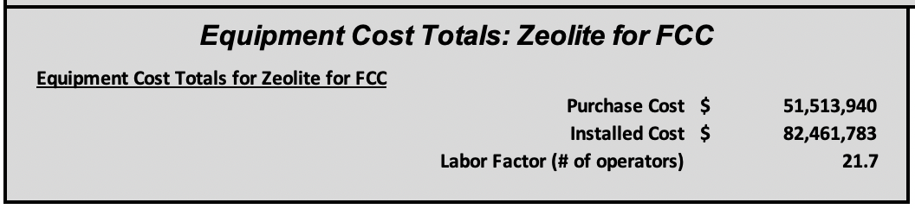

Figure 7.7. Equipment cost totals section of the equipment module.

### The “3c Utilities” Module

The “3c Utilities” module contains consumption inputs per unit catalyst and unit costs for six process utilities: cooling water, process water, low-pressure steam, high-pressure steam, electricity, and natural gas. The Excel version of the module is shown in . Entries in this module should correspond to the process design entered on “3b Equipment.” The section shown in allows editing of the unit costs only; to edit the consumption values, there is a section for each process template (Figure 7.9; see chapter for details on process templates).



Figure 7.8. The “3c Utilities” module in the Excel version of CatCost.

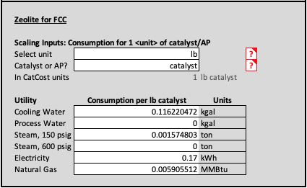

Figure 7.9. The consumption inputs section for the Zeolite for FCC process template in the Excel version of CatCost. In the upper section, inputs define how much catalyst (e.g., 1 lb catalyst, 1 kg active phase) the consumption values correspond to. In the lower section, consumption values are entered for each of six utilities.

### The “3d CapEx” and “3e OpEx” Modules

The outputs from the equipment list form the basis for estimation of the remainder of CatCost’s processing cost components, as described in Section . In the factored capital costs module “3d CapEx,” cost components like piping, installation, buildings, land, etc. are calculated from the total equipment purchase price using percentage factors. Default factors are provided from Peters & Timmerhaus,4 and the user can change any or all of the factors according to their own process design knowledge or to evaluate cost scenarios (). The factored operating costs module on “3e OpEx” is similar (), but with most costs based on the sum of direct labor requirements rather than the purchased equipment cost. The cost bases vary in the operating factors. Notably, Distribution and Marketing and Research and Development costs exclude the value of any precious/noble metals content using the “4 Spent Catalyst” module, so for catalysts containing these metals the calculation will not be complete until “4 Spent Catalyst” has been completed.



Figure 7.10. Factored Capital Costs on “3d CapEx.”



Figure 7.11. Factored Operating Costs on “3e OpEx.”

# Process Templates for the Step Method and CapEx & OpEx Factors Method

## Making estimates faster and more accessible

Many users of CatCost are not expected to have the experience in industrial chemistry or the access to process simulation tools, such as AspenPlus, needed to generate a detailed synthesis process design at industrial scale. Furthermore, even for experienced users, developing such a design may involve sizing 10–30 pieces of equipment with materials of construction, performing materials and energy balances, and undergoing optimization and revision to obtain a credible process design, a significant effort that may require days or weeks to complete. For this reason, CatCost-provided process templates are included in both the Step Method and the CapEx & OpEx Factors method for processing cost estimation. These templates are based on complete process models and have been entered in CatCost for easy selection by the user. We expect that this will aid both casual users or non-engineers who may have difficulty developing such designs on their own, and power users for whom the process designs will be an excellent starting point that they can then customize for greater accuracy and specificity. The bundled process templates were chosen to encompass the largest potential user-base and minimize the required user input to generate accurate estimates for the largest number of potential catalysts.

## Step Method templates

Templates in the step method consist of selected process steps (e.g., spray dryer) with alternates for different production scales in order to accommodate the entire 1–1000 ton range of step method order size (Figure 8.1). Twelve different step method templates are included in CatCost, and the user can easily select from among them or enter a custom process as shown in Figure 8.2.

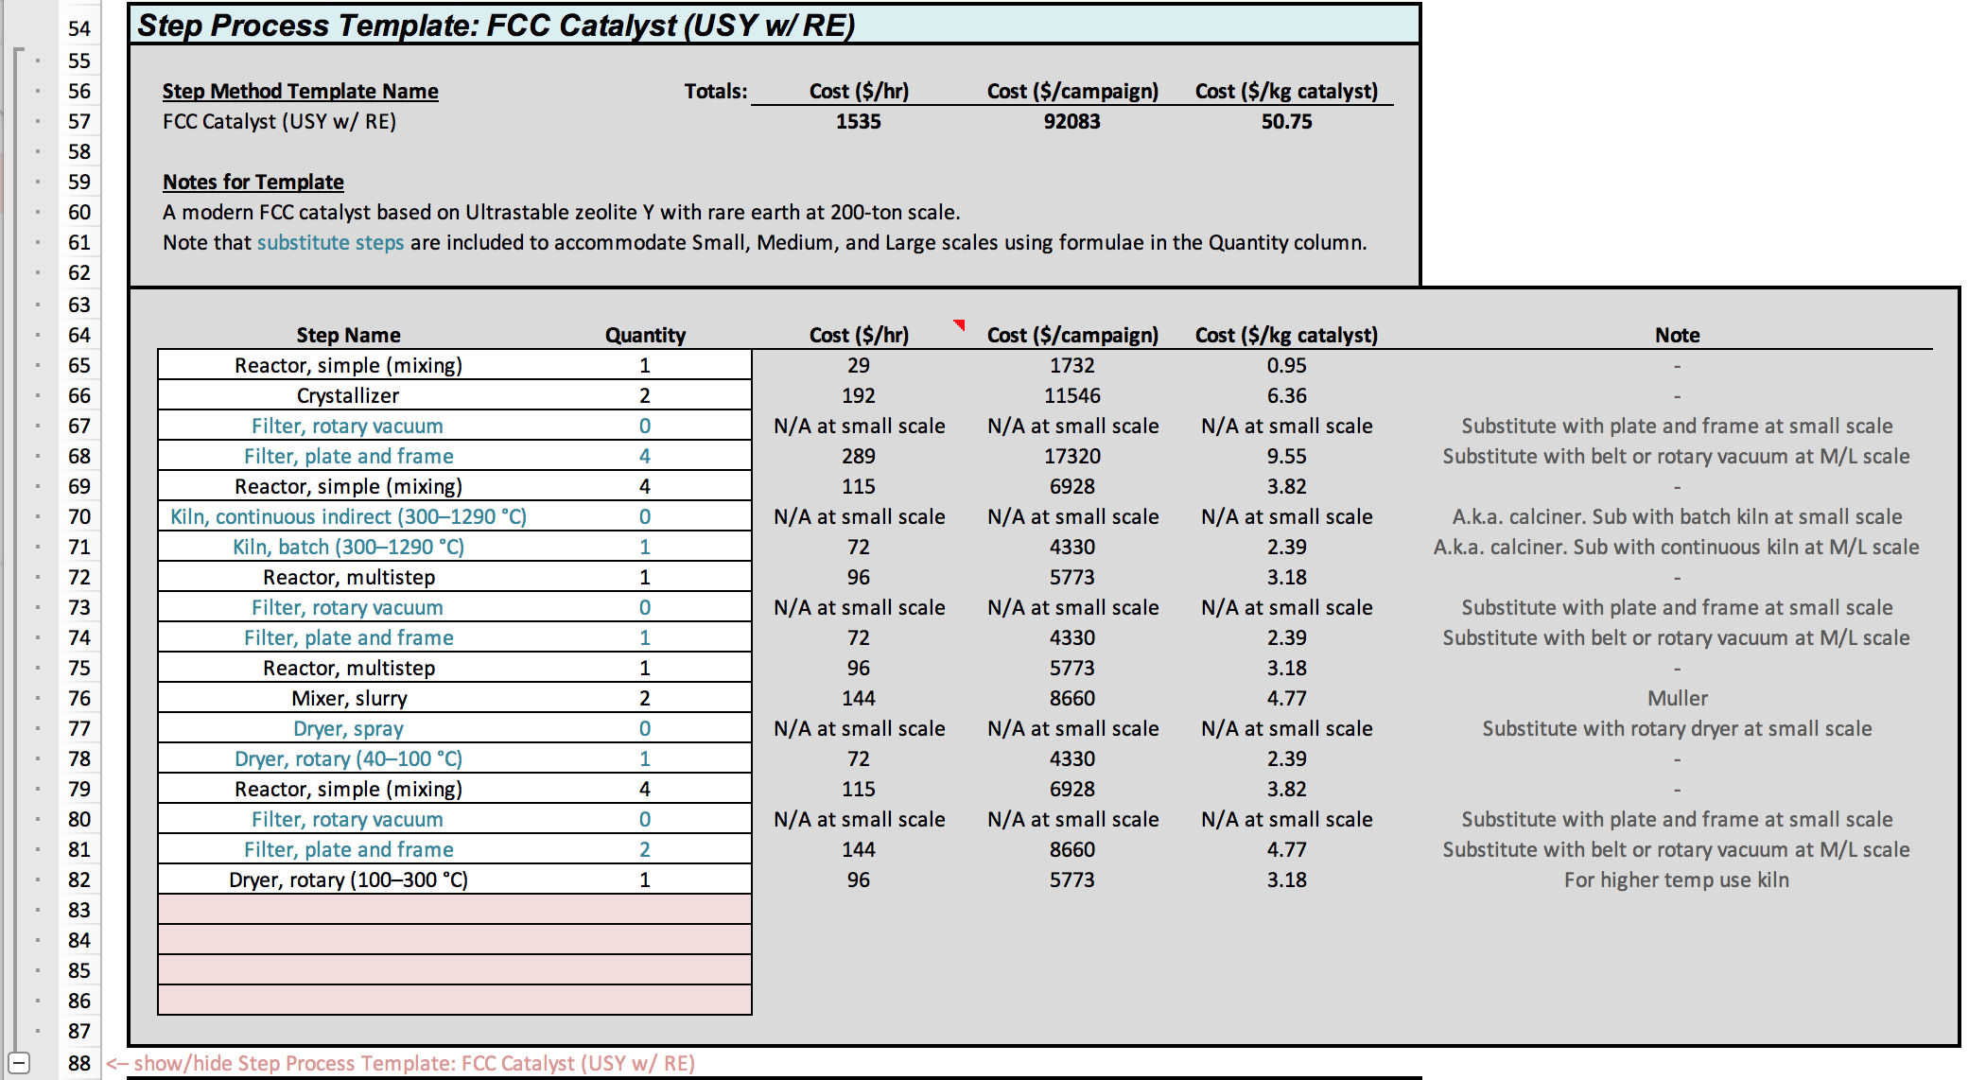

Figure 8.1. Screenshot of CatCost showing an exemplary step method process template: Production of an FCC catalyst at “Small” (1 ton/day) scale. Steps in green are not available at all production scales, so formulae automatically select the correct unit for that production scale for inclusion.

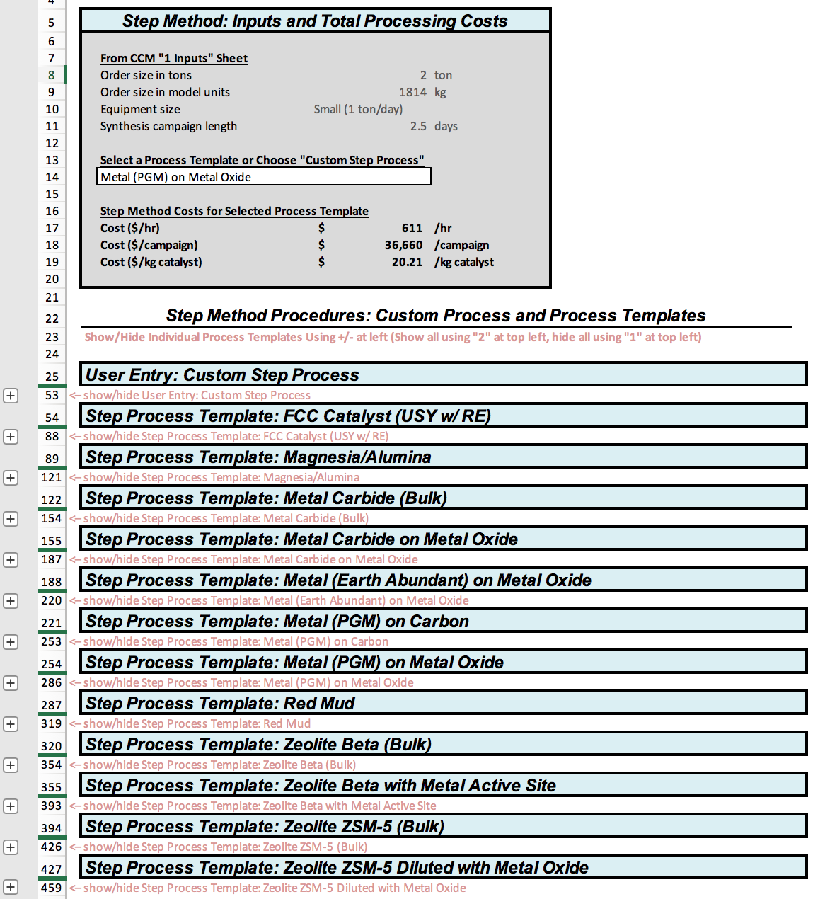

Figure 8.2. Overview screenshot of the Step Method section of CatCost, showing the range of 12 process templates included, as well as the ability to enter a custom process, and to easily select from this list for inclusion in an estimate.

## CapEx & OpEx Factors templates

Process templates in the CapEx & OpEx Factors method include a list of equipment items including size, quantity, and material of construction for a specified production scale of catalyst (see for an example of a process template equipment list and for the overall selection of a process template from the list), as well as a list of utilities consumption per mass unit of catalyst (see ).

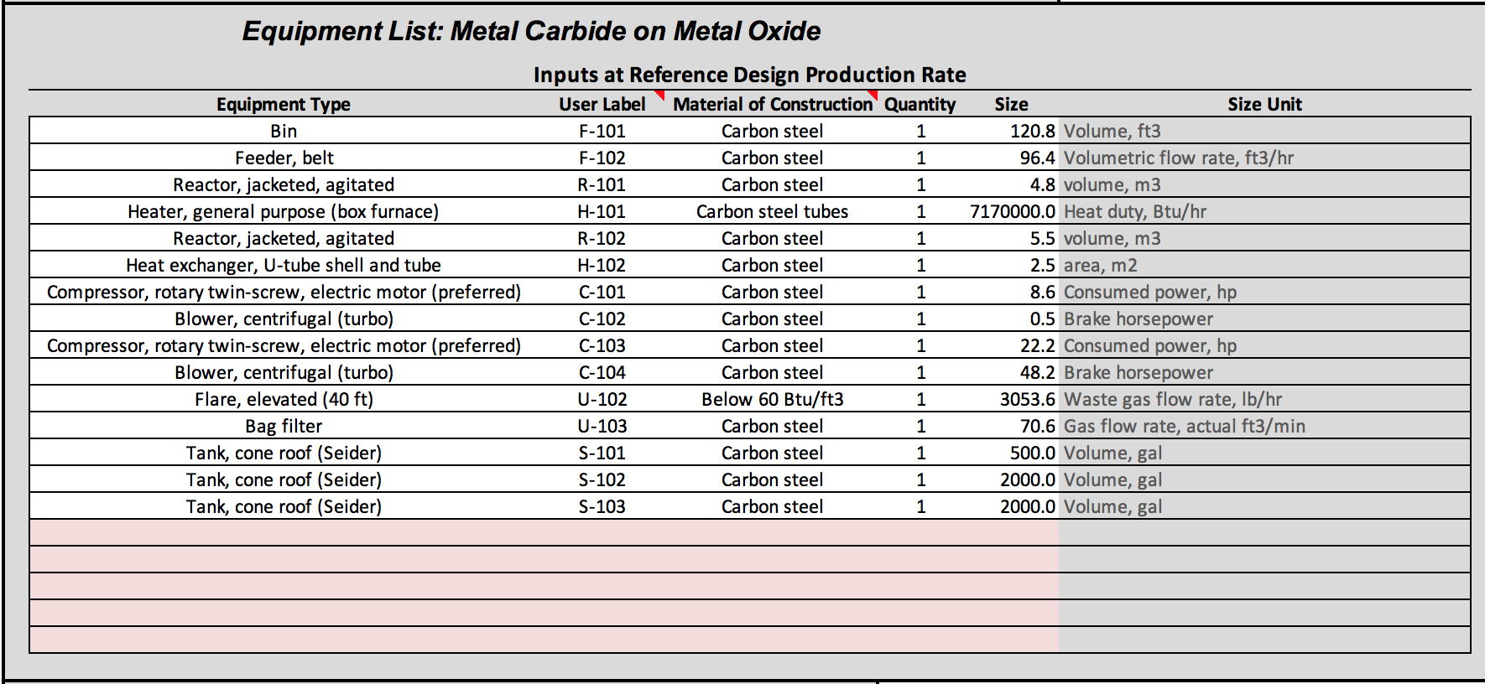

Figure 8.3. Screenshot from CatCost showing the equipment list from one of the CapEx & OpEx Factors Templates: Metal Carbide on Metal Oxide, including equipment items, sizes, quantities, and materials of construction.

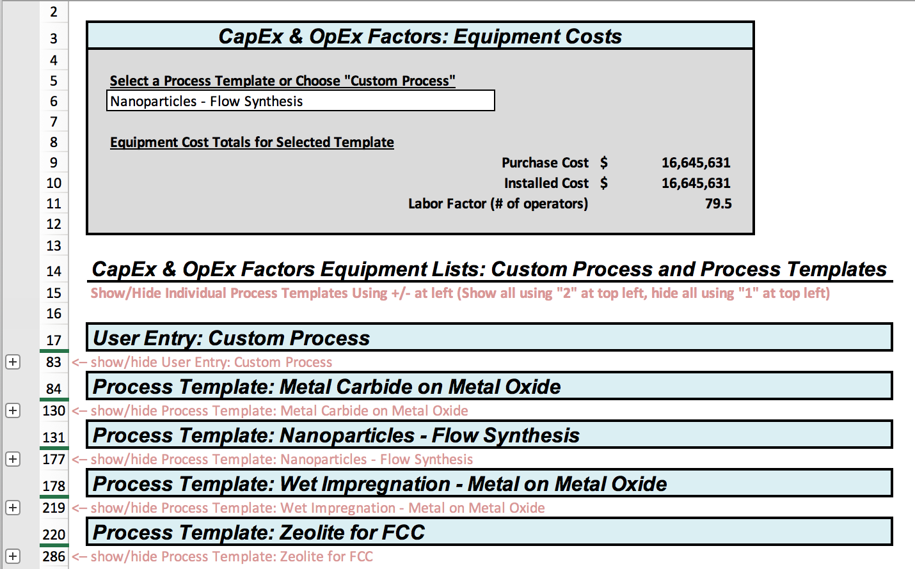

Figure 8.4. Overview screenshot from CatCost showing selection of a process template or custom process in the Equipment list section of the CapEx & OpEx Factors Method.

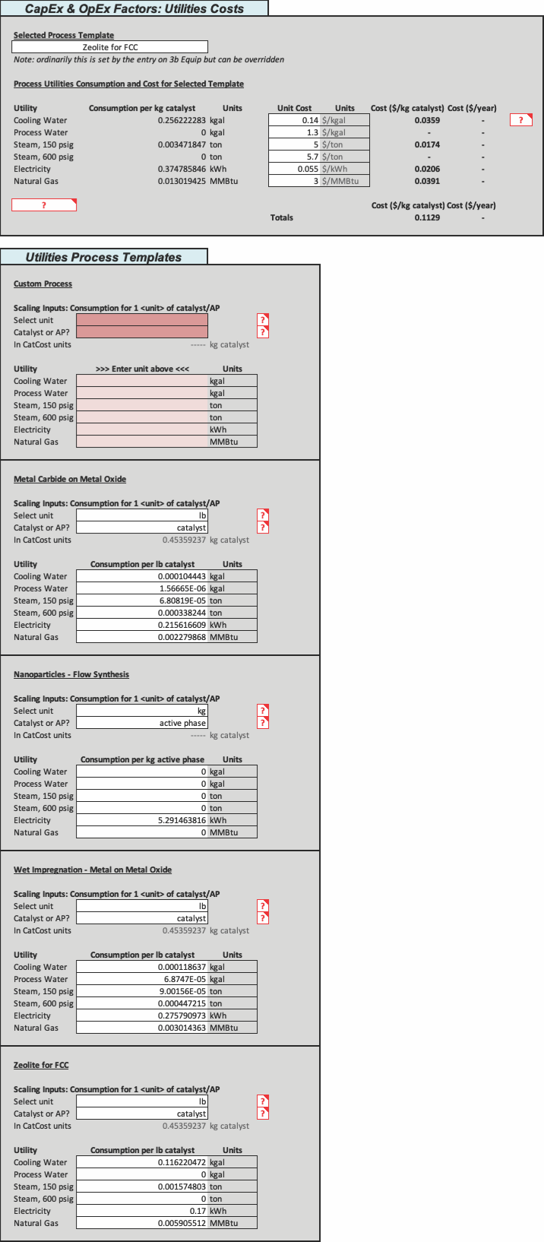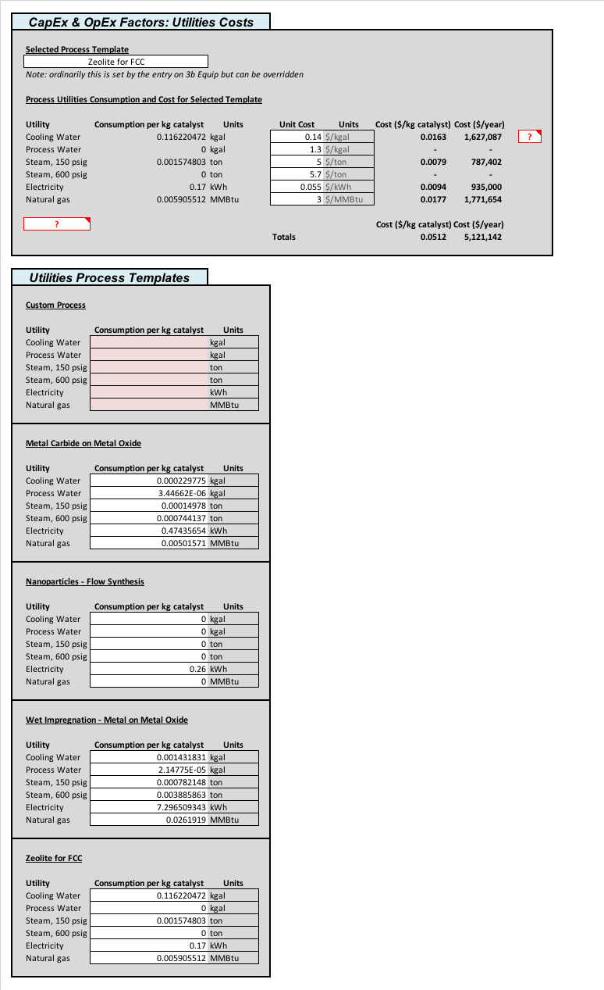

Figure 8.5. Screenshot from CatCost showing the Utilities portion of the CapEx & OpEx Factors method, with the ability to select from process templates to match those in the Equipment list.

# Spent Catalyst Value: The *“4 Spent Catalyst”* Module and *Spent Catalyst Library*

## Overview and “4 Spent Catalyst” Module

While the procedures outlined so far for estimating materials and processing costs allow CatCost to provide a complete estimate of the initial purchase/synthesis cost of a catalyst at industrial scale, the initial cost of filling a catalytic reactor is only part of the story. Accurate comparisons of catalytic materials must consider the differing values of catalysts at the *end* of their useful life. CatCost provides a Spent Catalyst Value module for this purpose, enabling comparisons between, for example, a molybdenum carbide catalyst with a relatively low purchase cost and a platinum-based catalyst with a high purchase cost but with significant spent catalyst value.

Within CatCost, the “4 Spent Catalyst” module estimates the value of three distinct options for spent catalysts: metals recovery, sale, and landfill. CatCost presents the value of each of the options and automatically chooses the most favorable option (i.e., if the cost to recover metal from a catalyst exceeds the value of the metal content to be recovered, CatCost first looks for sale value, and then finally chooses to landfill the catalyst if neither metals recovery nor sale were more favorable). Notably, CatCost presents the spent catalyst value as an individual line item in the catalyst cost outputs () so that the user can choose whether to include it in catalyst cost comparisons. This approach also allows the technoeconomic analysis-oriented user to enter the reactor filling and catalyst disposal inflows/costs at the appropriate times in a discounted cash-flow analysis of a catalytic process plant.



Figure 9.1. Excerpt from CatCost outputs showing the separate line item for Spent Catalyst Value.

The inputs to CatCost for the “4 Spent Catalyst” module are shown in below. These inputs, shared by the Excel and web versions of CatCost, allow the tool to look up values from the Spent Catalyst Library (described below) and to perform calculations. Built-in logic allows CatCost to determine the best-value option for the spent catalyst based on these inputs. For details of the logic being used, see the following sections. The first two inputs to “4 Spent Catalyst,” “Metal to recover” and “Support,” allow CatCost to estimate the attrition losses during catalyst use and metals refining, as well as to look up the appropriate spot metal price from the Spent Catalyst Library. The third input, “Metal wt. % of AP” (the weight fraction of the recoverable metal in the active phase; for example, for a Rh2P active phase this number is 86.92%), is used with the “Active Phase Weight Percent” field on “2 Materials” to determine the metal content in fresh catalyst. The fourth input, “Catalyst Bulk Density,” may be entered in units of either lb/ft3 or kg/m3 and is used in calculation of refiner “incoming” and “metal contaminant” fees (described below), both of which have a volumetric basis (e.g., $105/ft3). CatCost automatically converts the user-entered density according to the units chosen and conveniently provides a “Bulk Density Lookup Tool” with densities for common catalyst materials on the right side of the Excel spreadsheet and bottom of the web tool module. The fifth input, “Planned reactor configuration” accepts values of “Fixed Bed” and “Slurry/Fluidized Bed” and affects the calculation of attrition losses mentioned above, since fluidized beds cause greater catalyst attrition. The sixth input, “Has trace Sn, Cu, Fe > 2% of AP?” addresses the difficulty of recovering precious metals from catalysts contaminated with over 2% (by wt. % of the active phase) of any of the named metals, and triggers a “metal contaminant” fee in addition to fees charged to catalysts without these contaminants. The seventh and final input, in contrast to the forgoing inputs, determines to the sale value, if any, and landfill cost of the spent catalyst. It is entitled “Classification for Sale or Landfill” and accepts options such as “Zeolite, Silica, Alumina” and “Hazardous (e.g., RCRA metals).” For more information on the meaning of these options and selecting the appropriate classification for a catalyst, see the following sections.

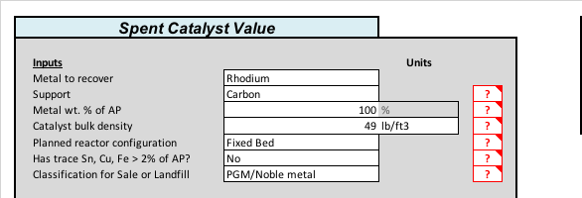

Figure 9.2. Inputs section of “4 Spent Catalyst” module in Excel, showing an estimate completed for a Rh/C catalyst.

## Spent Catalyst Recovery/Disposal Details and Calculation Logic

### Overview of options for managing spent catalyst

illustrates commonly available options for managing spent catalyst and key decision points for each. This decision logic has been incorporated in CatCost such that the “options” mentioned below are automatically selected to maximize spent catalyst value. In general, spent catalysts can be sent to a catalyst refiner and processed to reclaim metals, sold for other uses (e.g., steel, cement, or smelter), or disposed of in a landfill. Note that it is already assumed that plants employing catalytic materials will regenerate them as long and as often as it is economical to do so. Starting at the top of (“START”), spent hydrotreating and fluidized catalytic cracker (FCC) catalysts used in petroleum refineries are generally landfilled or sometimes sold to a cement or steel mill. Hydrotreating catalysts are designated as hazardous waste by the US Environmental Protection Agency (EPA) through the Resource Conservation and Recovery Act (RCRA),29 but if properly stabilized, can be deemed safe to handle and transport. These materials, once properly pretreated, can be regenerated, sold for their Mo, V or W content to be used in steel, or landfilled. FCC catalysts are generally not considered hazardous and do not require stabilization due to the highly encapsulated nature of the catalyst structure. For non-hydroprocessing/hydrorefining catalysts, the first step is to determine whether or not the spent material is hazardous waste (per RCRA and/or state regulations). If it is, the material may either be sent to a hazardous landfill, or it is possible that it may be sold to a catalyst refiner if there is enough PGM and they are equipped to process the material. For non-hazardous material, it first goes through a thermal oxidation step to remove residual volatiles, coke, and most of the sulfur resulting from catalytic processing. For non-PGM catalysts, it may or may not be economically justified to reclaim metals (e.g., Ni, Co, Cu) from the spent material. If the recovery option is chosen, the type of processing used will depend on the support. For Al2O3, SiO2 or carbonate supports, the support is first solubilized with an appropriate solvent (e.g., NaOH or H2SO4). The metals are then recovered from the insoluble residue via filtration, and hydrometallurgical processing is used to further purify and recover the metals. For clay, BaSO4, TiO2, and ZrO2 supports, the metals are leached (e.g., with a HCl / sodium chlorate mixture) from the support and then concentrated into a solution form for recovery and purification. For a metal “sponge” in which a high-surface-area metal is used as a catalyst with no supporting material, the sponge is first calcined and then solubilized and recovered similarly to silica- and alumina-supported catalysts.

For PGM catalysts, (see “PGM CATALYST” in ), it must first be decided whether or not to recover the metal, which depends on the identity of the PGM(s) and amount present in the spent material. Generally, if the material contains less than 0.2% PGM, the recovery option will be uneconomical and/or technically difficult. In this case, the material could either be landfilled or sold to a smelter or catalyst refiner (to add to their stockpile for later refining). If the recovery option is chosen, the processes described above for the oxide supported materials are applied. For carbon supported material, the initial thermal oxidation step destroys the support and the remaining metal is dissolved and recovered via hydrometallurgy.



Figure 9.3. Spent catalyst management options and associated costs.

The mathematical logic used for calculation of aggregated costs for each of the spent catalyst options is described in the following paragraphs. Default values for the key variables used in these calculations are given in the tables contained in the Spent Catalyst Library (described in Section ).

### Metals Recovery Option:

If the option to reclaim spent catalyst is chosen, the value associated with reclaiming metal from the spent catalyst is counted as a credit towards the manufacturing cost to calculate an overall adjusted catalyst cost:

$$C_{adjusted}=C_{manufacturing}- V_{reclaimed}$$

Where $C_{adjusted}$ is the overall adjusted cost of the catalyst in $/lb catalyst purchased with $C_{manufacturing}$ and $V_{reclaimed}$ defined below.

$C_{manufacturing}$ = manufacturing cost ($/lb catalyst purchased)

$V_{reclaimed}$ = reclaimed catalyst value ($/catalyst purchased)

$V_{reclaimed}$ is calculated as:

$$V_{reclaimed}=V_{metal}- C_{recovery}$$

$$V_{metal}$$ is the salvage value of the metal ($/lb catalyst purchased) and is calculated as

$$V_{metal}={(1-L}_{metal-use})× {(1-L}_{metal-ref})×M_{loading}×P$$

Where

$L_{metal-use}$ = metal loss from use phase (lb metal lost/lb metal on fresh catalyst)

$L_{metal-ref}$ = metal loss from catalyst refining process (lb metal lost/lb metal on spent catalyst)

$M_{loading}$ = metal loading on catalyst (lb/lb fresh catalyst)

*P* = metal spot price ($/lb)

$C_{recovery}$ is the cost to recover the metal ($/lb catalyst purchased) and is calculated by summing the fees for each of the processing steps shown in the block diagrams () (thermal oxidation, dissolution/leaching and hydrometallurgy, and refining charge for Platinum Group Metal (PGM) catalysts):

$C_{recovery}={(1-L}_{solids-use})×{{(F}_{thermox}+F_{Incoming}/ρ)+(F_{refining}× M_{loading})×(1-L_{metal-use})×(1-L}_{metal-ref})$

Where

$F_{thermox}$ = thermal oxidation fee ($/lb catalyst treated)

$F_{incoming}$ = incoming fee for metals recovery processing (typically dissolution/leaching + hydrometallurgy) (lb/ft3 catalyst treated)

*ρ* = catalyst bulk density (lb/ft3)

= refining fee ($/lb PGM metal recovered)

$L_{solids-use}$ is the total catalyst solids lost during the use phase (resulting from loading, attrition, metal not staying attached, and unloading), (lb catalyst loss/lb fresh catalyst), and is calculated as:

$$L_{solids-use}={(L}_{support-use})×{\left(1-M_{loading}\right)+(L_{metal-use})×M}_{loading}$$

Where

$L_{support-use}$ = loss of support during use phase (lb support/lb fresh catalyst)

CatCost default values for the variables used in the above equations are given in Section .

### Sale Option:

If the spent catalyst is sold for other purposes, the overall Adjusted Catalyst Cost is calculated as:

$$C_{adjusted}=C_{manufacturing}-{(1-L}_{solids-use})×\left(V_{sale}\right)$$

Where $V_{sale}$ is the sale value available from various buyers. The applicable sale values are given in Section .

In the case of a molybdenum containing catalyst, $V_{sale}$ is calculated as

$$V_{sale}=M_{moly}×{(1-L}_{metal-use})×1.5 ×\left(P_{MoO3}\right)×\left(X\right)$$

Where

$M_{moly}$ = Loading of Mo on catalyst (lb Mo/lb catalyst purchased)

$P_{MoO3}$ = Price of MoO3 ($/lb)

0.15-0.40 (adjustment factor, fraction of MoO3 value)

(Factor of 1.5 is the molecular weight ratio of MoO3 to Mo)

### Landfill Option:

If neither metals recovery nor sale is a viable option for a spent catalyst, it must be landfilled at additional cost. This is particularly likely in the following scenarios:

1. Hydroprocessing and hydrorefining catalysts are deemed RCRA hazardous waste by the US EPA but can be treated/stabilized to render the waste non-hazardous and subsequently disposed of in a non-hazardous waste landfill.
2. If a spent catalyst contains any of the RCRA metals (“Big 8”), Toxicity Characteristic Leaching Procedure (TCLP) testing is needed to determine whether or not it is hazardous waste. The TCLP limits are provided in the Spent Catalyst Library (next section) (hazardous determination is accomplished solely through testing and working with a company’s regional regulatory authorities).
3. If a PGM catalyst contains less than 0.2% PGM, the PGM cannot be easily recovered so it would likely go to landfill.

The adjusted catalyst cost in the case of the landfill option is calculated as:

$$C_{adjusted}=C_{man}+ C_{landfill}$$

Where $C_{landfill}$ is the overall cost to landfill ($/lb catalyst purchased) and is calculated as:

$$C_{landfill}={(1-L}_{solids-use})×\left(F_{thermox}+F_{landfill}\right)$$

Where

$F_{landfill}$ is the landfill fee ($/lb catalyst landfilled)

Typical landfill fees included in CatCost are given in Section .

## The Spent Catalyst Library

The Spent Catalyst Library included in CatCost provides default values for the variables used in calculations in “4 Spent Catalyst,” as described in the previous section. The user may change or add to the entries in the Spent Catalyst Library to suit their estimation needs. The Spent Catalyst Library contains the same information described below, but implemented into five tables with slightly different grouping and different numbering than in this report.

gives average losses of the support and active phase metal during catalyst use, which are used in the calculation of spent catalyst solids remaining after unloading of the reactor. presents typical metal losses that occur during catalyst refining. lists average thermal oxidation and incoming fees charged for the different support types. lists typical fees charged by the catalyst refiner. lists estimated catalyst bulk densities. The Toxicity Characteristic Leaching Procedure (TCLP) limits are listed in and include a 20-fold dilution of waste (weight basis) in acetic acid, per EPA Test Method 1311.30 Also listed are the corresponding minimum concentrations of metals that would need to be present in the spent catalyst material to possibly exceed the TCLP limits (assuming 100% of the metal leaches out of the spent catalyst). This table is provided here and in CatCost for informational purposes only and hazardous determination is accomplished solely through testing and working with the proper regulatory authorities. The list of applicable landfill fees for calculation of spent catalyst disposal is listed in . presents typical selling prices for spent catalyst sold for other uses, such as cement, a smelter, or metals refiner.

Table 9.1. Average values of support and metal losses from use phase.

|  |  |  |  |  |
| --- | --- | --- | --- | --- |
| **Support** | **Fixed** | | **Slurry/Fluidized** | |
|  |  |  |  |  |
| TiO2 | 2% | 10% | 3% | 13% |
| ZrO2 | 2% | 10% | 3% | 13% |
| SiO2 | 2% | 3% | 2% | 4% |
| Al2O3 | 2% | 3% | 2% | 4% |
| Carbon | 2% | 2.5% | 6% | 5% |
| Carbonate | 5% | 5% | 5% | 5% |
| Sponge of metal | n/a | 5% | n/a | 5% |
| Clay | 5% | 5% | 5% | 5% |

Table 9.2. Metal loss from refining.

|  |  |  |  |
| --- | --- | --- | --- |
| **Metal** | **High** | **Low** | **Average** |
| ***PGMs*** | | | |
| *Palladium* | 4% | 1% | 3.5% |
| *Platinum* | 3% | 1% | 3.0% |
| *Rhodium* | 10% | 5% | 7.5% |
| *Ruthenium* | 25% | 15% | 20.0% |
| *Gold* |  |  | 10.0% |
| *Iridium* |  |  | 10.0% |
|  |  |  |  |
| ***Non-PGMs*** | | | |
| Aluminum  (Claus, misc) |  |  | 70% |
| Cobalt |  |  | 20% |
| Copper CuZn | 25% | 15% | 20% |
| Iron |  |  | 40% |
| Molybdenum | 30% | 20% | 25% |
| Nickel |  |  | 20% |
| Silver | 2% | 3% | 2.5% |
| Tungsten NiW | 25% | 15% | 20% |

Table 9.3. Thermal oxidation fees (*Fthermox*) and incoming fees (*Fincoming*) for metals recovery processing (typically dissolve/leach + hydrometallurgy).

|  |  |  |  |
| --- | --- | --- | --- |
| **Process/ Variable** | **Support** | $F_{thermox}$**(low) $/lb** | $F_{thermox}$**(high) $/lb** |
| *Thermal Oxidation* | All | 0.125 | 0.15 |
|  | | | |
| **Process / Variable** | **Support** | **(low) $/ft3** | **(high) $/ft3** |
| *Incoming Fee for Processing* – (<2% Cu, Fe, Sn of PGM) | Carbon | 94 | 115 |
| Al2O3, SiO2, TiO2, ZrO2, carbonate, clay | 108 | 123 |
| Sponge*a* | 81 | 92 |
| *Incoming Fee for Processing*– (>2% Cu, Fe, Sn of PGM)*b* | Carbon | 115 | 130 |
| Al2O3, SiO2, TiO2, ZrO2, carbonate, clay | 126 | 137 |
| Sponge*a* | 95 | 103 |

*a* Estimated at 30% less costly than with hard supports.

*b* Applies to catalysts that contain Cu, Fe, or Sn at >2% of the main PGM or non-PGM metal.

Table 9.4. Refining Charge - $F_{refining}$.

|  |  |
| --- | --- |
| Metal | $/TrOz Recovered |
| Pt | 14.5 |
| Pd | 12.5 |
| Rh | 16 |
| Au | 11 |
| Ru | 20 |
| Ir | 25 |
| Ag | 11.5 |

Table 9.5. Catalyst bulk densities provided to users as a guide.

|  |  |  |
| --- | --- | --- |
| **Catalyst** | **ρ (lb/ft3)** | **Note** |
| Activated C powder | 42 | Containing 50% moisture |
| Activated C granules | 46 | Containing 50% moisture |
| Metal on Al2O3 | 45 | dry extrudate |
| Metal on TiO2 | 65 | dry extrudate |
| Metal on ZrO2 | 66 | dry extrudate |
| Al2O3/SiO2, 44%/51% | 50 | dry extrudate |
| SiO2, 3/16" | 30 | dry spheres |
| Sponge Ni, Co, or Cu | 71.25 | Dry basis; average of 67.5-75 lb/ft3 |

Table 9.6. RCRA metals and Toxicity Characteristic Leaching Procedure limits, along with *estimated* minimum concentrations in a catalyst that would be expected to cause a material to exceed the TCLP limit and be regulated under RCRA.

|  |  |  |
| --- | --- | --- |
| **Metal** | **TCLP Limit, mg/L** | **Minimum Concentration in Catalyst, wt%** |
| As | 5 | 0.01% |
| Ba | 100 | 0.20% |
| Cd | 1 | 0.002% |
| Cr | 5 | 0.01% |
| Pb | 5 | 0.01% |
| Hg | 0.2 | 0.0004% |
| Se | 1 | 0.002% |
| Ag | 5 | 0.01% |

Table 9.7. Landfill Fees (*Flandfill*).

|  |  |  |
| --- | --- | --- |
| **Catalyst Type** | **Fee (per pound catalyst)** | **Notes** |
| Zeolite, Silica, Alumina | $0.15-0.20/lb | e.g., FCC |
| Ni/Mo, Co/Mo, Ni/W | $0.75/lb | Includes stabilization |
| PGM | $1-3/lb | May include stabilization |
| Hazardous Waste | $1-3/lb | E.g., contains Big 8>TCLP limits |

Table 9.8. Sale Values (*Vsale*)

|  |  |  |
| --- | --- | --- |
| **Catalyst Type** | **Value** | **Notes** |
| Zeolite, Silica, Alumina | $0.05/lb catalyst | e.g., for cement |
| PGM | $1-1.30/lb catalyst | e.g., to smelter or refiner, typically <0.2% PGM |

# 

# Outputs

A CatCost estimate is summarized on the “5 Outputs” module in the spreadsheet version and in the “5a Summary Outputs” and “5b Detailed Outputs” modules in the web app version. The spreadsheet “5 Outputs” and web app “5a Summary Outputs” have the same breakdown of costs. However, in v1.1.0, the spreadsheet version includes separate results summaries for the Step Method, for CapEx & OpEx Factors, and a combination of the Step Method / CapEx & OpEx Factors, whereas the web app does not include the Step Method feature and so its outputs reflect the CapEx & OpEx Factors method only.

The breakdown of costs in “5a Summary Outputs” is similar to the financial-style summary published by other cost estimators, such as the IHS Markit Process Economics Program. Notably, materials and utilities costs are included in the operating cost total. The “5b Detailed Outputs” page on the web uses a different breakdown in which Materials and Utilities have their own top-level headers and are *not* included in the Operating Cost category, which includes labor and factored operating costs only.

# Web Tool Data Import/Export and Visualizations

## Importing/Exporting Data in the CatCost Web Tool

The CatCost webtool has been designed with data import and export functionalities to allow users to export any dataset they have in the CatCost tool to their local machine in the form of a .json file. CatCost can export any individual library (e.g., the *Materials Library*, the *Equipment Library*, or the *Spent Catalyst Library*), any individual estimate, or the complete portfolio of estimates from the *Catalyst Estimates* page. These .json files can then be imported into the webtool to resume work on an estimate and can be easily shared with colleagues. This section outlines the import and export features of the CatCost tool and how they can be used effectively to save and share estimates and cost libraries.

Exporting data from CatCost is easy, and this option is always located in the “File” dropdown menu (). It is important to note that the “Download JSON file” option is contextual, meaning that it will download the information that is displayed on whatever page you are currently on. For example, notice in that on the main “Estimates” list page the file menu displays the option to “Download Estimate Set JSON file”. This option downloads all estimates in the CatCost tool to a single .json file. On all other pages, the download JSON button in the file dropdown menu will only download the data from that page. For example, while browsing the “Materials Library” page the option to “Download Materials Library JSON file” is displayed ().



Figure 11.1. File menu import and export options available from the main “Estimates” page.



Figure 11.2. File menu import and export options available from the main “Materials Library” page.

Importing data is just as simple and uses the same contextual options as described above for exporting data. To import an estimate set simply visit the main “Estimates” page, hover the cursor over the file menu shown in , and select the “Open Estimate Set JSON file” option and a dialog for importing estimates will appear. You may then choose from the following two options, to open a dataset from the ChemCatBio Data Hub or to upload your own estimate file. At the top of the dialog you can select to download a set of default catalyst estimates that the CatCost team has made available on the Data Hub (these may be limited at the initial release of the tool). To import an estimate that has previously been created in the CatCost tool, simple drag and drop the file from your local machine to box highlighted in the left pane of . CatCost will then verify the contents of the file to ensure it is compatible with the current version of the tool, and if successful the filename will appear in green and the “Import from File” button will change from gray to green as shown in the right pane of . The page will then be refreshed and populated with the estimate or library that was just imported.



Figure 11.3. The import dialog for Catalyst Estimates (Left) and a successfully verified .json ready for import (right).

*Important Note:* This import operation is contextual and can be performed from any page of the CatCost tool. Be careful to only select .json files that correspond to the correct data type for the open page. For example, only select .json files that contain a “Materials Library” for import while on the “Materials Library” page; otherwise the file will fail to import. The data type is displayed at the top of each import dialog box.

Python scripts that are currently under development will be provided to aid users in transferring estimates and libraries between the Excel and web versions of CatCost. This will allow users to easily apply the benefits of each tool to a single estimate.

*Note: the web version stores all user-entered content (estimates and libraries) locally in the browser used to access the tool. While the browser will check the CatCost website for an updated version of the tool each time it is run,* ***no user-entered information, proprietary or otherwise, is transmitted to or stored on CatCost/ChemCatBio web servers****. This means that in order to retrieve previously entered estimates or library entries, the user must open the same browser on the same computer that was used to build them, or the information must be downloaded as a JSON file. The user is therefore advised to back up their estimates and libraries as described above.*

## Visualizations in the CatCost Web App

The web version of CatCost has the added functionality of powerful visualizations that can be manipulated in real time. The CatCost web app includes three visualization options for catalyst purchase cost that enable users to interact with their cost estimate beyond the capabilities of Excel, including a Sankey Diagram, an interactive cost breakdown “donut chart,” and a customizable pie chart as shown in b-d. These visualizations can be accessed while editing an estimate by placing the cursor over the “Visualize” menu on the estimation navigation toolbar as shown in a and selecting one of the visualization options. The web app also includes two sensitivity analysis visualizations.



Figure 11.4. The drop-down menu to access the interactive visualizations of cost data (a) including the Sankey diagram (b) interactive donut chart (c) and composable pie chart and (d).

The Sankey diagram highlights the hierarchical relationships of all cost contributors and enables the visualization of the flow of cost through an estimate. The data shown can be adjusted by clicking on any of the cost contributors, which collapses all sub-cost contributors in that category and removes them from display. The “donut” chart has been designed to facilitate analysis by allowing users to “drill” into any section and view what cost components contribute to that section simply by clicking on any cost component of interest either on the chart itself or from the table. The pie chart allows users to build their own graphics directly from the interface, selecting only the categories they wish to be visualized with a simple check/uncheck option available for each category.

# References

1. Anderson, J. Determining Manufacturing Costs. *Chem. Eng. Prog.* January 2009, pp 27–31.

2. Anderson, J. Communicating the Cost of Product and Process Development. *Chem. Eng. Prog.* February 2010, pp 46–51.

3. Anderson, J.; Fennell, A. Calculate Financial Indicators to Guide Investments. *Chem. Eng. Prog.* September 2013, pp 34–40.

4. Peters, M. S.; Timmerhaus, K. D. *Plant Design and Economics for Chemical Engineers*, 5th ed.; McGraw-Hill: New York, 2003.

5. This terminology comes from a common five-category system used in the industry, in which “preliminary” or “study-grade” is the fourth-most-accurate category. The categories have been standardized by AACE International, an industry group, which further specifies that the error in a preliminary estimate can be expected to be 3–12 times that of an estimate in the most accurate category, variously called “detailed” or “check estimate”. *Cost Estimate Classification System*; AACE report 17R-97; AACE International: Morgantown, WV, 2011.

6. Desai, M. B. Preliminary cost estimating of process plants. *Chem. Eng. (New York)* July 27, 1981, pp 65–70.

7. The U.S. Bureau of Labor Statistics Chemical Producer Price Index including data since 1984 may be accessed at <http://data.bls.gov/cgi-bin/srgate> under accession code PCU325---325---.

8. Seider, W. D.; Lewin, D. R.; Seader, J. D.; Widagdo, S.; Gani, R.; Ng, K. M. *Product and Process Design Principles: Synthesis, Analysis and Evaluation*, 4th ed.; Wiley: Hoboken, NJ, 2016.

9. Qi, W.; Sathre, R.; Morrow, W. R.; Shehabi, A. *Unit price scaling trends for chemical products*; LBNL-189844; Lawrence Berkeley National Laboratory: Berkeley, California, 2015.

10. <http://www.icis.com/chemicals/channel-info-chemicals-a-z/>

11. Fisher Scientific. Nickel(II) acetate tetrahydrate, 99+%, for analysis, ACROS Organics. <https://www.fishersci.com/shop/products/nickel-ii-acetate-tetrahydrate-99-analysis-acros-organics-4/p-4510213> (accessed September 12, 2016).

12. Alibaba.com. Nickel (II) acetate tetrahydrate 6018-89-9 (Purity: Ni>23%). <https://www.alibaba.com/product-detail/Nickel-II-acetate-tetrahydrate-6018-89_60407232611.html> (accessed September 12, 2016).

13. Baddour, F. G.; Snowden-Swan, L.; Super, J. D.; Van Allsburg, K. M. Estimating Precommercial Heterogeneous Catalyst Price: A Simple Step-Based Method. *Org. Process Res. Dev.* **2018**, *22* (12), 1599–1605.

14. Augustine, R. L. *Heterogeneous Catalysts for the Synthetic Chemist*; Marcel Dekker: New York, 1996.

15. *A Practical Guide to Catalyst Testing*; 4816 TE; Catalytica: Mountain View, CA, 1987.

16. Super, J. D. The Precious Metal Loop, Costs from an Operating Company Perspective. *Top. Catal.* **2010**, *53* (15-18), 1138–1141.

17. Capes, C. E., Particle Size Enlargement. In *Handbook of Powder Technology*, Williams, J. C.; Allen, T., Eds. Elsevier: Amsterdam, 1986; Vol. 1.

18. Market prices derived from personal communications with catalyst industry experts.

19. (a) Guthrie, K. M. Data and Techniques for Preliminary Capital Cost Estimation. Chem. Eng., March 24, 20091969, pp 114–142. (b) Guthrie, K. M. Process Plant Estimating, Evaluation, and Control; Craftsman: Solano Beach, California, 1974. (c) Review of reference b: Maund, J. K. Engr. Process Econ. 1976, 1, 241–243.

20. Brown, T. R. Estimating Product Costs. *Chem. Eng. (New York)* August 2000, pp 86–89.

21. Ward, T. J., Economic Evaluation. In *Kirk-Othmer Encyclopedia of Chemical Technology (online)*, Wiley: New York, 2001.

22. Ulrich, G. D.; Vasudevan, P. T. *Chemical Engineering Process Design and Economics*, 2nd ed.; Process: Durham, New Hampshire, 2004.

23. Towler, G.; Sinnott, R. K. *Chemical Engineering Design – Principles, Practice, and Economics of Plant and Process Design*, 2nd ed.; Butterworth-Heinemann: Amsterdam, 2013.

24. Garrett, D. E. *Chemical Engineering Economics*; Van Nostrand-Reinhold: New York, 1989.

25. Feng, Y.; Rangaiah, G. P. Evaluating Capital Cost Estimation Programs. *Chem. Eng. (New York)* August 2011, pp 22–29.

26. Lang, H. J. Cost Relationships in Preliminary Cost Estimation. *Chem. Eng. (New York)* October 1947, pp 117–121.

27. Lang, H. J. Simplified Approach to Preliminary Cost Estimates. *Chem. Eng. (New York)* June 1948, pp 112–113.

28. Hand, W. E. From Flow Sheet to Cost Estimate. *Petroleum Refiner* **1958**, *37* (9), 331–334.

29. Federal Register, Volume 63, Issue 151 (63 FR 42110), August 6, 1998.

30. Reference: SW-846 Test Method 1311: Toxicity Characteristic Leaching Procedure. <https://www.epa.gov/hw-sw846/sw-846-test-method-1311-toxicity-characteristic-leaching-procedure>